**This Month’s University of Ottawa Diagnostic Questions**

**Question 1:**



|  |  |  |  |  |  |
| --- | --- | --- | --- | --- | --- |
| **A)** |  | **B)** |  | **C)** |  |
| **D)** |  | **E)** |  | **F)** |  |

**Question 2:**



|  |  |  |  |  |  |
| --- | --- | --- | --- | --- | --- |
| **A)** |  | **B)** |  | **C)** |  |
| **D)** |  | **E)** |  | **F)** |  |

**Question 3:**

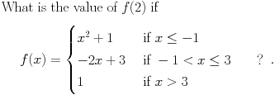

**Question 4:**

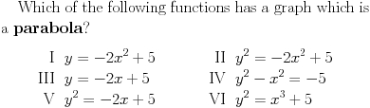

**Question 5:** 

|  |  |  |  |  |  |
| --- | --- | --- | --- | --- | --- |
| **A** |  | **B** |  |  |  |
| **C** |  | **D** |  |  |  |

**E  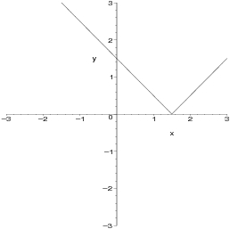 F** 