The Verruckt Water Slide Task

Expectation | R- | R+ | 1 | 2 | 3 | 4
Graphing Polynomial Functions
Graphing Rational Functions
Solving Polynomial and Rational Functions

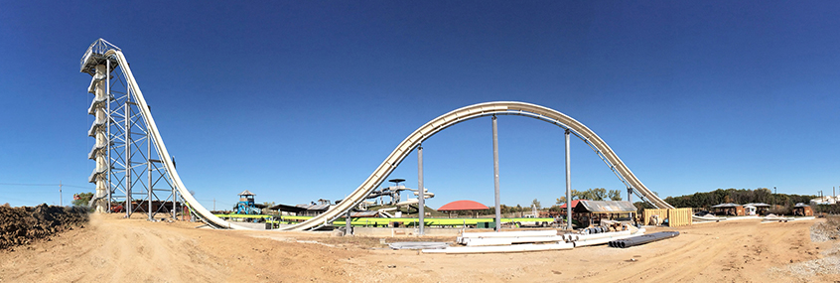

Above is the Verruckt water slide – the world’s tallest water slide. Your task is to use Desmos to model the water slide. Your Desmos graph should compare vertical height to horizontal distance.

You can Google “Verruckt” to find out more about the waterslide. The more you know about the water slide, the better your model will be.

Your model should be a combination of at least 2 functions – including a rational and polynomial function.

Using your model, determine the local max/min of the waterslide.

