Sports Spheres

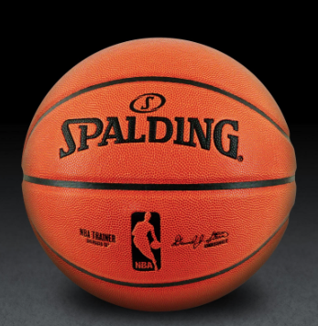
How many times bigger is a basketball in
comparison to a tennis ball?

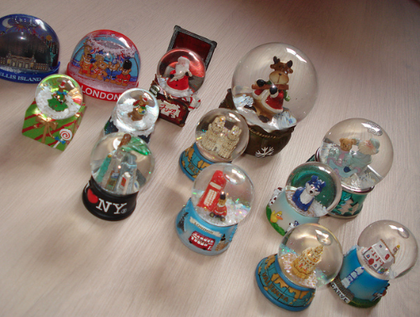
Snowglobe Spheres

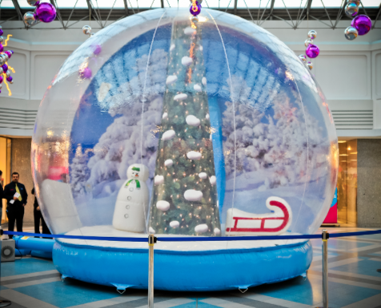

About how much more water would you need inside of the larger snow globe?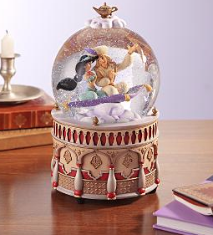

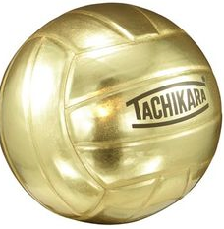Determine the amount of air that goes inside a volleyball.
26 inches

Determine the amount of air that goes inside a volleyball.
26 inches

26 inches
Determine the amount of air that goes inside a volleyball.

