PROBLEM 1:
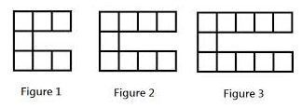
How can you represent?

Table
Graphs
Words: Increasing/Decreasing
Linear/Non-Linear
Initial Value
Rate of Change
Differences
Constant
Equations
Blocks

Represent the pattern as many ways as possible.

Figure Number | Number of Blocks
1
2
3
4
5
6

PROBLEM 2:
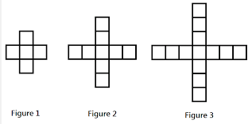

Represent the pattern as many ways as possible.

PROBLEM 3:
Represent the pattern as many ways as possible.

Figure Number | Number of Blocks
1
2 | 11
3 | 14
4
5

