Flying to India Through Toronto

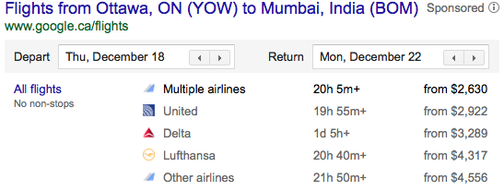
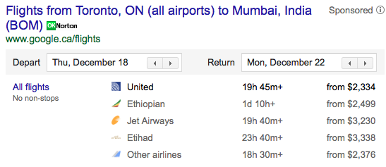
- Ms. Thangaraj’s Family drives 80km/h
- Wariso’s Family drives 100km/h
- Mery’s Family changes speed throughout the drive and stops at a restaurant to eat.

Ms. Thangaraj’s Family
Time | Distance From Home
0 | 0
1
2
3
4
5 | 400

Wariso’s Family
Time | Distance From Home
0 | 0
1
2
3
4 | 400

Mery’s Family
Time | Distance From Home
0 | 70
1 | 180
2 | 250
3 | 300
4 | 300
5 | 400

Represent the 3 families’ trip in different ways on a poster: tables, graphs, words, other…

