Numeracy: Operations Lesson #1 - Addition
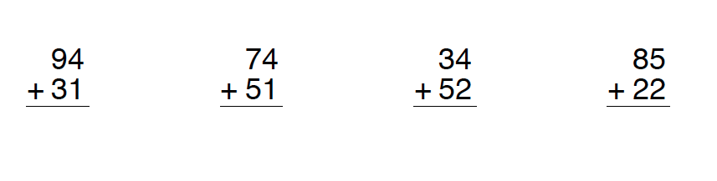

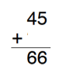 | 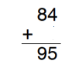 | 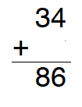

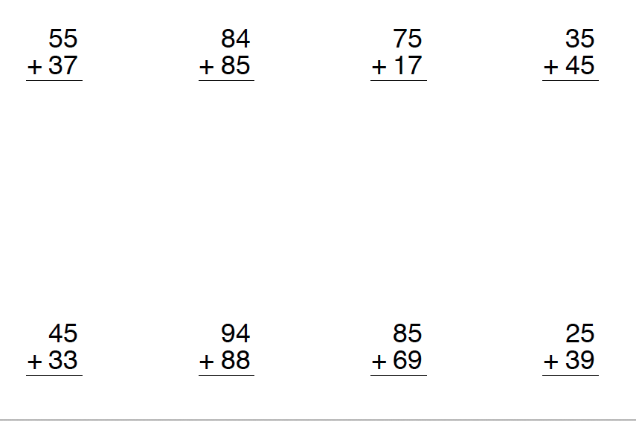

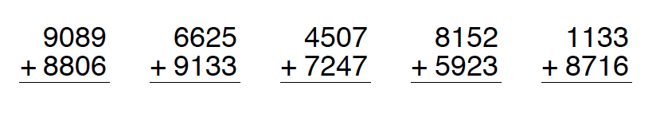

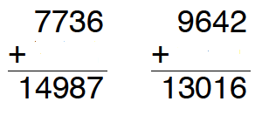

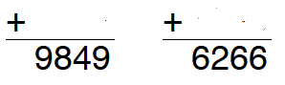

Item | Image | Price
Chocolate Bar |  | $1.76
Case of Chips | 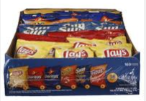 | $21.89
Large Bag of Candy |  | $3.47
Crate of Oranges | 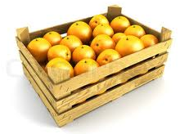 | $15.76
Gum |  | $0.82

Tuesday : Subtracting

subtract two-digit numbers, using a
variety of mental strategies (e.g., one way to
calculate 73 – 39 is to subtract 40 from 73
to get 33, and then add 1 back to get 34);

– solve problems involving
subtraction of four-digit numbers, using
student-generated algorithms and standard
algorithms (e.g.,“I added 4217 + 1914
using 5000 + 1100 + 20 + 11.”);

–subtract decimal numbers to
tenths, using concrete materials (e.g.,
paper strips divided into tenths, base ten
materials) and student-generated algorithms
(e.g.,“When I added 6.5 and 5.6,
I took five tenths in fraction circles and
added six tenths in fraction circles to give
me one whole and one tenth. Then I
added 6 + 5 + 1.1, which equals 12.1.”);

–subtract money amounts by
making simulated purchases and providing
change for amounts up to $100, using a
variety of tools (e.g., currency manipulatives,
drawings);

Thursday : Adding and Subtracting and Estimating

use estimation when solving problems
involving the addition, subtraction, and
multiplication of whole numbers, to help
judge the reasonableness of a solution
(Sample problem: A school is ordering
pencils that come in boxes of 100. If there
are 9 classes and each class needs about
110 pencils, estimate how many boxes the
school should buy.).

