Money and Decimals

How many pennies 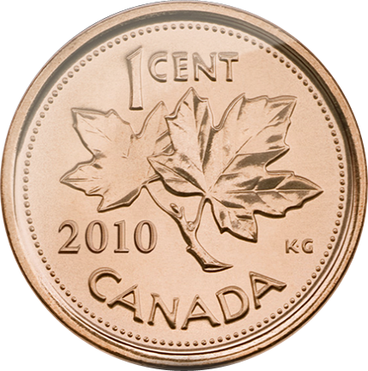 are in $1 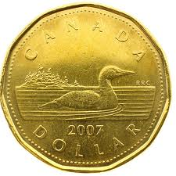?

How do you write 1 penny as a decimal? $ _____________

What place value does the 1 have? _______________________

How many dimes 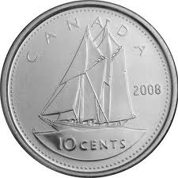 are in $1 ?

How do you write 1 dime as a decimal? $ _____________

What place value does the 1 have? _______________________

What is 27 pennies as a decimal? $ ______________________

27 pennies = _____ dimes and ________ pennies

What is 98 pennies as a decimal? $ ______________________

98 pennies = _____ dimes and ________ pennies

Game!

Roll | Number of Dimes | Number of Pennies | Money Amount in $
1
2
3
4
5
6
7
8
9
10
Total

Roll | Number of Dimes | Number of Pennies | Money Amount in $
Start |  |  | Total From Game 1:  ___________________
1
2
3
4
5
6
7
8
9
10
Total Remaining

