MHF4U Test 1 Review

Test will be Monday…
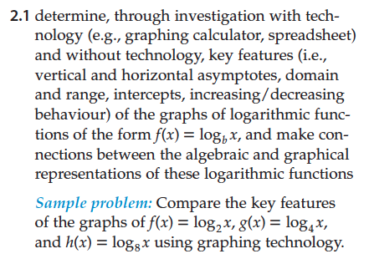
- Determine key features of an exponential function (asymptotes, domain and range, intercepts, increasing/decreasing behaviour, end behaviour).

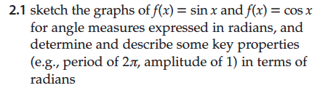
- Sketch f(x) = sin(x) and f(x) =cos(x) for angle measures expressed in degrees.
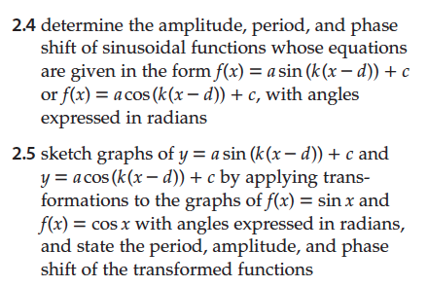
- Determine amplitude, period, and phase shift of sinusoidal functions whose equations are given in the form f(x) =a sin(k(c-d)) +c, with angles in degrees.

- Sketch the graph of a sinusoidal function.

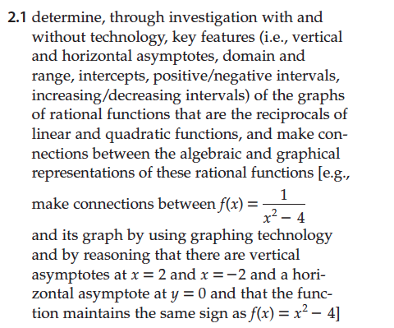
- State the key features of reciprocal functions (vertical and horizontal asymptotes, domain and range, intercepts, positive/negative intervals, increasing/decreasing intervals, end behaviour)

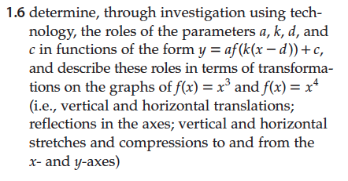
- Describe how the “a”, “k” “d” and “c” affect parent functions from grade 11.

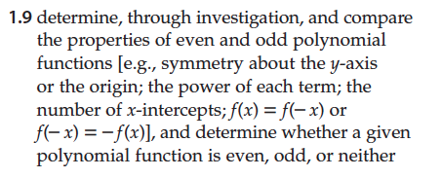
- Determine if a function is even or odd
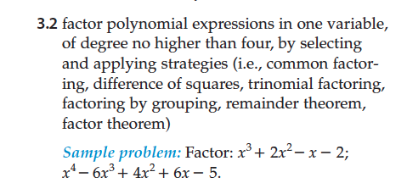
- Factor polynomials as required in grade 11.

