MCV4U – Summative

1. Find the area of the largest rectangle that can be inscribed in a semicircle of radius 14.

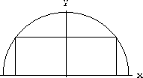

2. Financial analysts use graphical models to predict stock values for a new stock. A brand new stock is also called an IPO (initial public offering). When a stock is first issued it sells for more than it is really worth. One model for a class of Internet IPO’s predicts the percent overvaluation of a stock as a function of time as R(t) = 250[(t²/2.718^{3t})], where R(t) is the overvaluation in percent and t is the time in months after the initial issue of the stock.
- Use the information provided by the first derivative, second derivative and asymptotes to prepare advice for clients as to when they should expect a signal to prepare to buy or sell (inflection point), the exact time when they should buy or sell (local max/min) and any false signals prior to a horizontal asymptote. Explain your reasoning.
- Make a sketch without using a graphing calculator. Show all the steps your used to sketch it with accuracy.

3. After analyzing the population data of a bacteria colony, a microbiologist determines that the population of the bacterial colony can be modeled by the equation P(t) = 500e ^{0.1t}.
- What is the initial population of the bacteria colony?
- What function describes the instantaneous rate of change in the bacteria population after t hours?
- What is the instantaneous rate of change in the population after 1 hour? What is the instantaneous rate of change after 8 hours?
- How do your answers for part c. help you to make a prediction about how long the bacteria colony will take to double in size? Make a prediction for the number of hours the population will take to double, using your answers for part c, and/or other information. Give justifications for your prediction.
- Determine the actual doubling time – the time that the colony takes to grow to twice its initial population.
- Compare your prediction for the doubling time with the calculated value. If your prediction was not close to the actual value, what factors do you think might account for the difference?
- When is the instantaneous rate of change equal to 500 bacteria per hour?

4. The position of a particle is given by s=6sin(2t+ π/4) at time t. What are the maximum values of the displacement, the velocity and the acceleration?

5. A pipeline engineer needs to find the line that will allow a new pipeline to intersect and join an existing pipeline at a right angle. The existing line has a pathway determined by the equation L₂: r = (1,1,1,) + d(0,2,3), d is in the real numbers. The new pipeline will also need to be exactly 2 units away from the point (4,0,2).

- Determine the vector and parametric equations of L₃, the line that passes through (4,0,2) and is perpendicular to L₂.
- Determine the vector and parametric equations of L₁, the line that is parallel to L₃ and 2 units away from (4,0,2). There will be exactly two lines that fulfill this condition
- Plot each line of the coordinate axes.

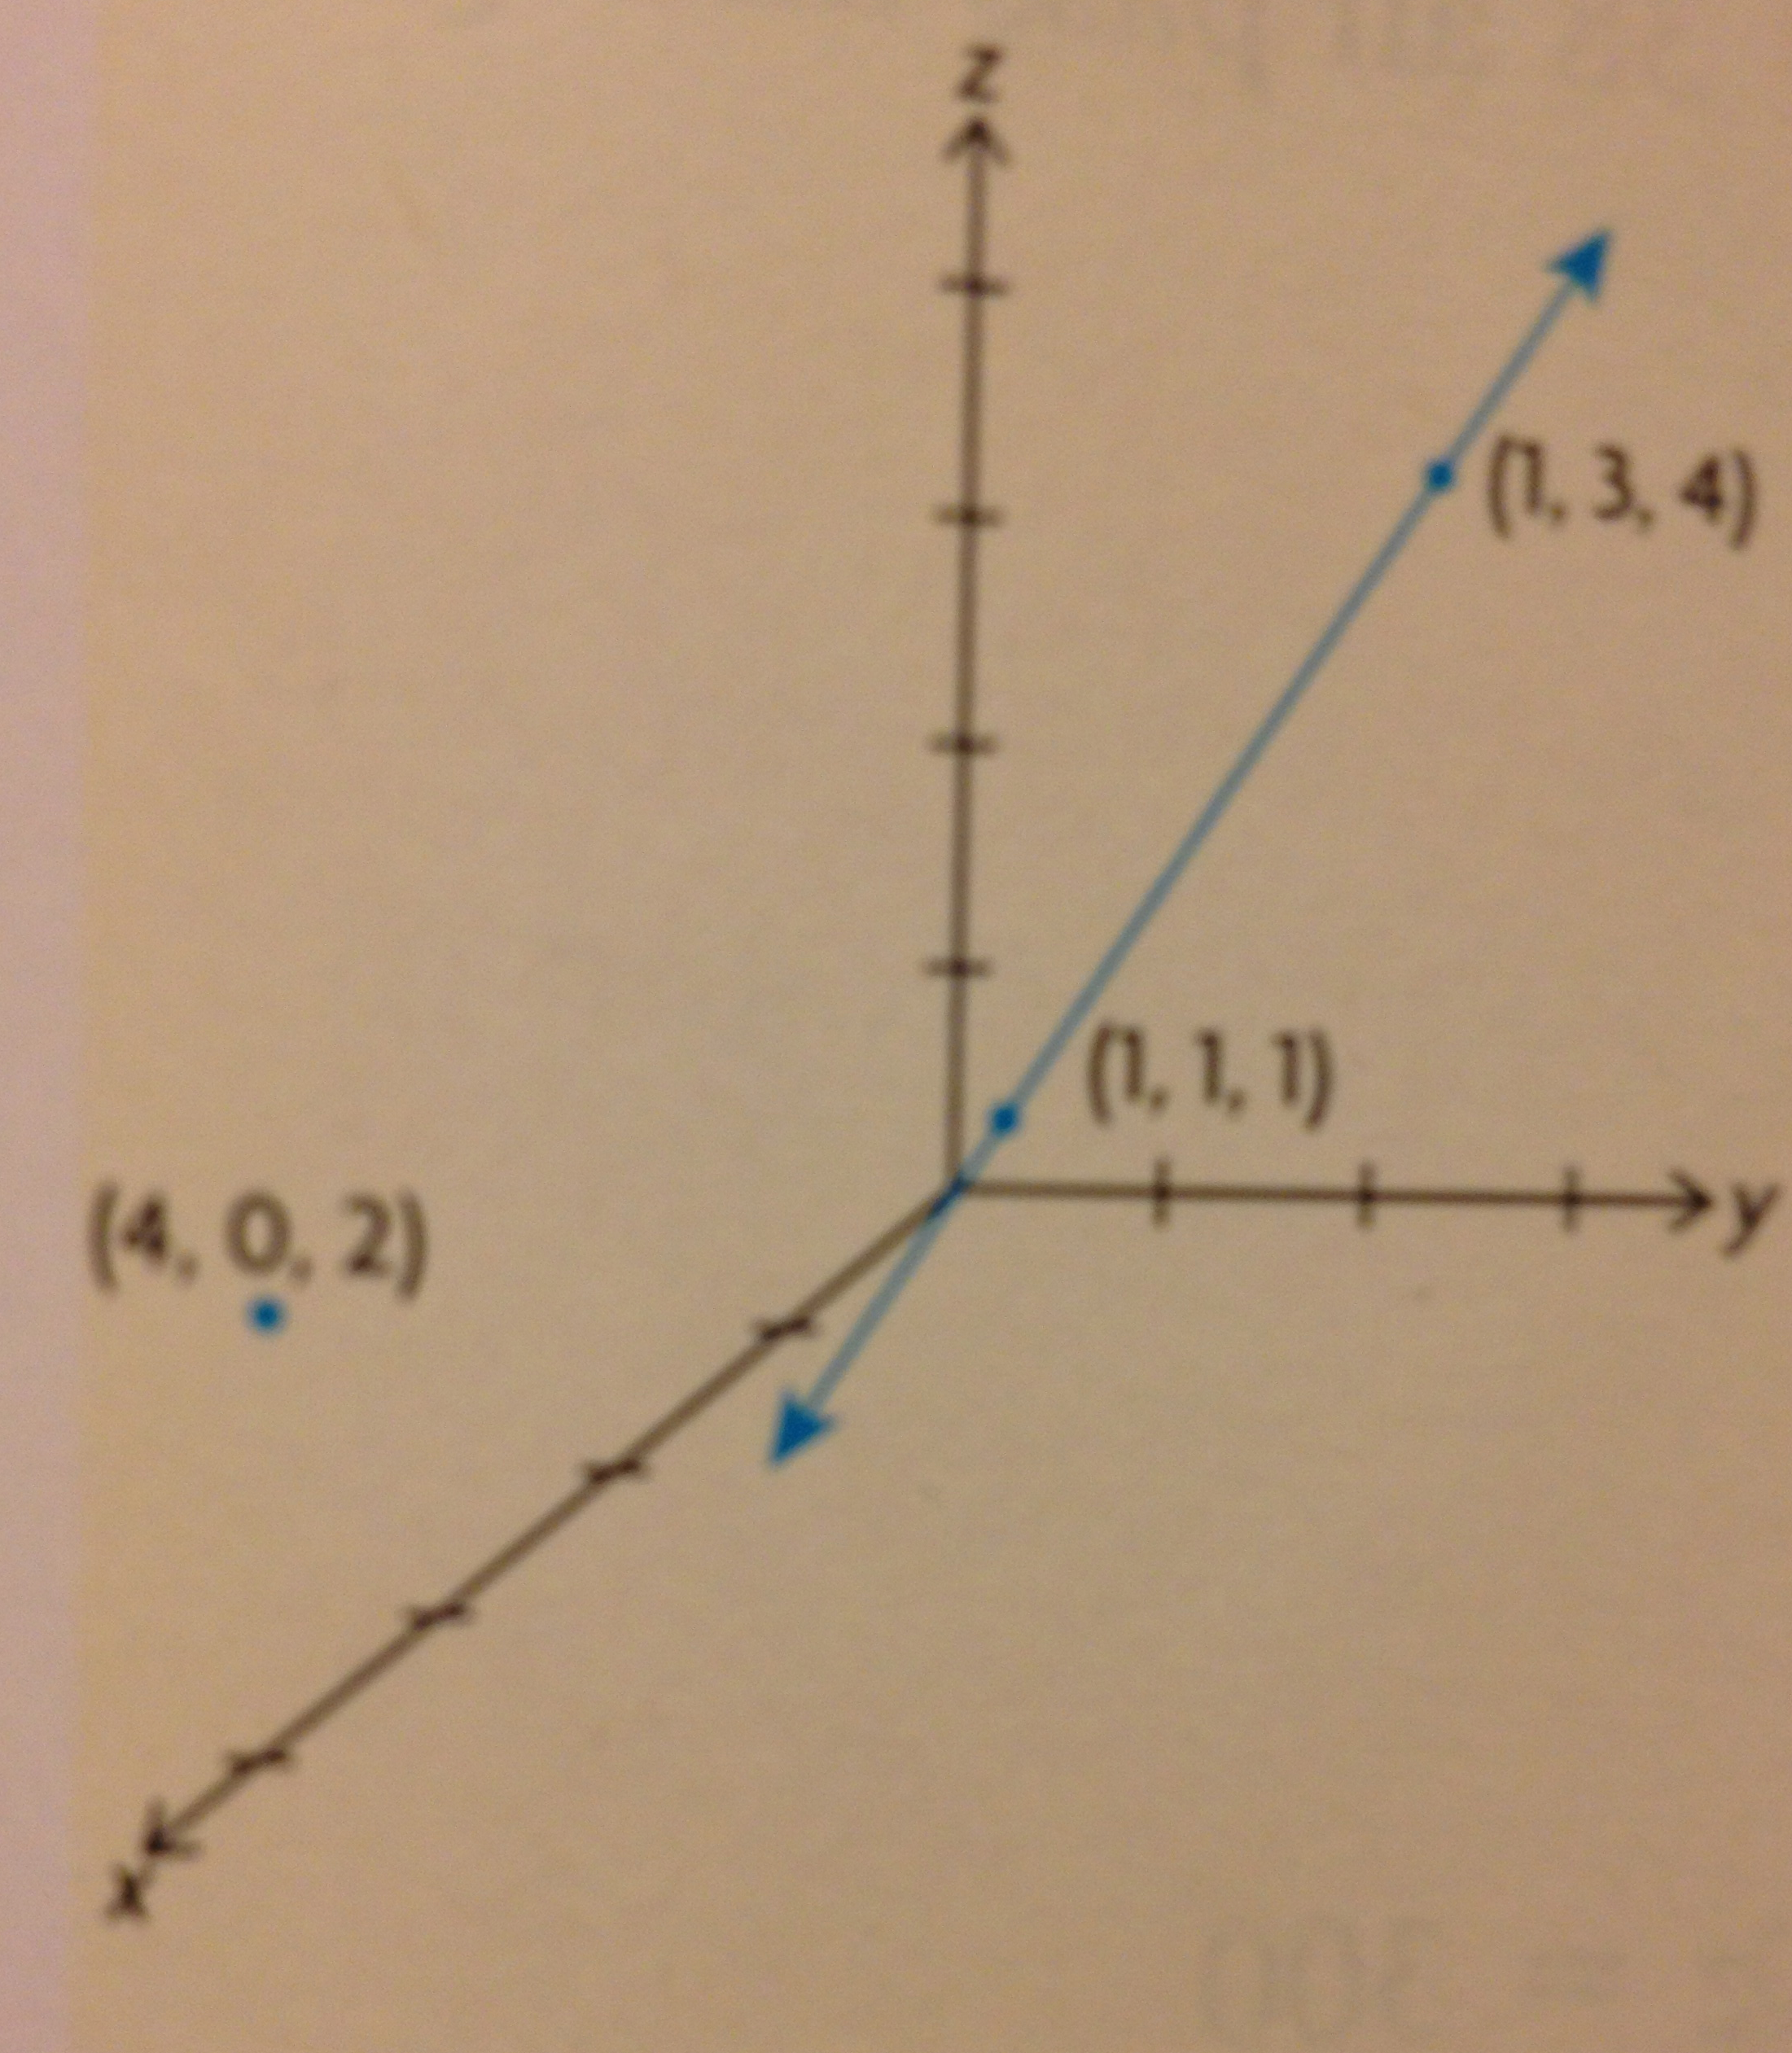

Categories | 50-59%  (Level 1) | 60-69%  (Level 2) | 70-79%  (Level 3) | 80-100%  (Level 4)
Knowledge and Understanding - Subject-specific content acquired in each course (knowledge), and the comprehension of its meaning and significance (understanding)
Knowledge of content  (e.g., facts, terms, procedural skills, use of tools) | demonstrates limited knowledge of content | demonstrates some knowledge of content | demonstrates considerable knowledge of content | demonstrates thorough knowledge of content
Thinking - The use of critical and creative thinking skills and/or processes
Use of planning skills  -understanding the problem (e.g., formulating and interpreting the problem, making conjectures)  -making a plan for problem solving | uses planning skills with limited effectiveness | uses planning skills with moderate effectiveness | uses planning skills with considerable effectiveness | uses planning skills with a high degree of effectiveness
Use of processing skills  -carrying out a plan (e.g., collecting data, questioning, testing, revising, modelling, solving, inferring, forming conclusions)  -looking back at the solution (e.g., evaluating reasonableness, making convincing arguments, reasoning, justifying, proving, reflecting) | uses processing skills with limited effectiveness | uses processing skills with some effectiveness | uses processing skills with considerable effectiveness | uses processing skills with a high degree of effectiveness
Communication - The conveying of meaning through various forms
Expression and organization of ideas and mathematical thinking (e.g., clarity of expression, logical organization), using oral, visual, and written forms (e.g., pictorial, graphic, dynamic, numeric, algebraic forms; concrete materials) | expresses and organizes mathematical thinking with limited effectiveness | expresses and organizes mathematical thinking with some effectiveness | expresses and organizes mathematical thinking with considerable effectiveness | expresses and organizes mathematical thinking with a high degree of effectiveness
Use of conventions, vocabulary, and terminology of the discipline (e.g., terms, symbols) in oral, visual, and written forms | uses conventions, vocabulary, and terminology of the discipline with limited effectiveness | uses conventions, vocabulary, and terminology of the discipline with some effectiveness | uses conventions, vocabulary, and terminology of the discipline with considerable effectiveness | uses conventions, vocabulary, and terminology of the discipline with a high degree of effectiveness
Application - The use of knowledge and skills to make connections within and between various contexts
Application of knowledge and skills in familiar contexts | applies knowledge and skills in familiar contexts with limited effectiveness | applies knowledge and skills in familiar contexts with some effectiveness | applies knowledge and skills in familiar contexts with considerable effectiveness | applies knowledge and skills in familiar contexts with a high degree of effectiveness
Transfer of knowledge and skills to new contexts | transfers knowledge and skills to new contexts with limited effectiveness | transfers knowledge and skills to new contexts with some effectiveness | transfers knowledge and skills to new contexts with considerable effectiveness | transfers knowledge and skills to new contexts with a high degree of effectiveness

