8.5 – The Cartesian Equation of a Plane
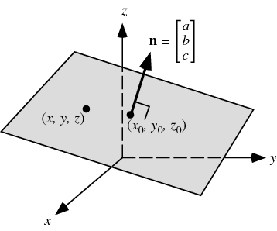
Suppose you know a point on the plane, then [x-x₀,y-y₀, z-z₀] is a vector on the plane. Since the normal is perpendicular to the plane, [x-x₀,y-y₀, z-z₀] • [a,b,c] = 0. We use this fact to come up with the Cartesian Equation of the plane.

Example: A plane contains point (2,4,-1) and has normal [3,1,-4]. Determine the equation of the plane.

Notice: It is easy to find a normal to a plane! Use the cross product since the cross product yields a vector perpendicular to two vectors.

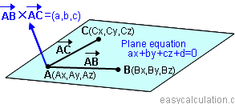
Example: Determine the Cartesian equation of the plane that has points A(-3,2,1), B(4,2,1) and C(-1,-4,5)

Example: Determine the Cartesian form of a plane whose vector form is

Example: Determine the vector and parametric equations of the plane with Cartesian equation ______________________________
What is true about the normals for two planes that are parallel?

What is true about the normal of two planes that are perpendicular?

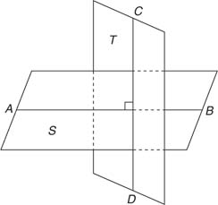

How can you find the angle between two intersecting planes?

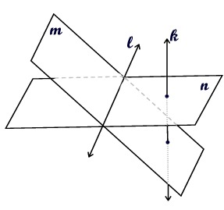

Example: Show that the two planes are perpendicular.
π1: 3x – 2y +4z +3 = 0 and π2: 10x +5y – 5z +8 = 0

Example: Show that the two planes are parallel.
π1: 3x – 2y +4z +3 = 0 and π2: 15x -10y +20z +8 = 0

Example: Determine the angle between the two planes.
π1: 5x – 2y +2z +3 = 0 and π2: x +5y – 2z +8 =
Homework: pg468 #1-14

