7.6 and 7.7 Summary of Cross Product AND Applications of Dot and Cross Product
REVIEW – FRIDAY AND TUESDAY
TEST – WEDNESDAY

The cross product of a and b gives you a vector that is perpendicular to both a and b.
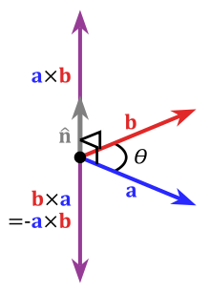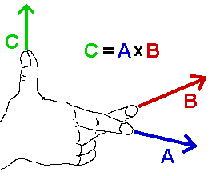
FORMULA 1:
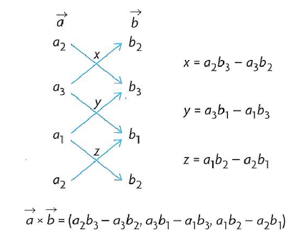
Example: Find the cross product of a=(1,3,6) and b=(4,-2,3)

Example: Find a vector perpendicular to both (1,3,2) and (4, -6, 7)

FORMULA 2:

Example: Calculate the cross product, u x v, if the magnitude of v is 50 and the magnitude of u is 80 and the angle between them is 52 degrees.
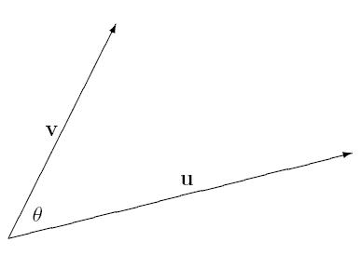

CROSS PRODUCT APPLICATION: The cross product will give you the area of the parallelogram formed by a and b.
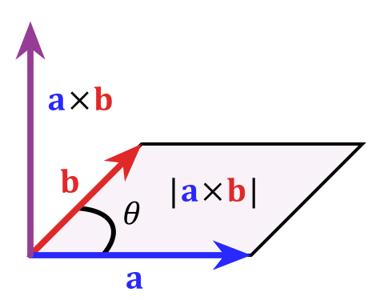
Example: Calculate the area of the parallelogram with sides represented by the vectors (4,2,-1) and (-1,-3,-1)

CROSS PRODUCT APPLICATION: Torque

Loosely speaking, torque is a measure of the turning force on an object such as a bolt or a flywheel. For example, pushing or pulling the handle of a wrench connected to a nut or bolt produces a torque (turning force) that loosens or tightens the nut or bolt.
The symbol for torque is typically τ, the Greek letter tau. When it is called moment, it is commonly denoted M.
The magnitude of torque depends on three quantities: the force applied, the length of the lever arm connecting the axis to the point of force application, and the angle between the force vector and the lever arm. In symbols:
Where
τ is the torque vector and τ is the magnitude of the torque,
r is the displacement vector and r is the length of the lever arm vector measured in m.
F is the force vector, and F is the magnitude of the force,
θ is the angle between the force vector and the lever arm vector.

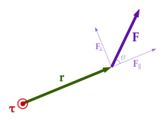
Example: A 20 N force is applied at the end of a wrench that is 30 cm in length. The force is applied at an angle of 55 degrees to the wrench. Calculate the magnitude of the torque about the point of rotation M.

DOT PRODUCT APPLICATION: WORK - When a force is acting on an object so that the object is moved from one point to another, we say that the force has done work.

Work = f•s,

where f is the force acting on an object, measured in Newtons (N); s is the displacement of the object, measured in metres (m); and W is the work done, measured in joules (J).

Example: Santa is pulling a sleigh and is exerting a force of 50N acting at 28° to the ground. If Santa pulls the sleigh a distance of 100 m, how much work was done?

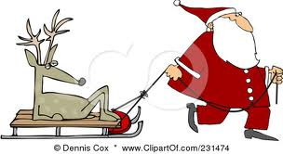

Work = f•s = ⏐ f⏐⏐s⏐cosθ

Homework: pg 407 #3, 4d,e,f, 5,11; pg. 415 #2, 3, 4a,d, 5b, 6,8

