Linear Relations Lesson 7b

Find the initial value and the rate of change for the sentence, table and graph. Then determine the equation.

Sentence: The monthly cost for a cellphone is fixed at $45.00.

Table:
Number of km, n | Cost to rent a car, C, in $
0 | 200
100 | 200
200 | 200
300 | 200

Initial Value: ____________
Rate of Change: ________

Equation: _______________

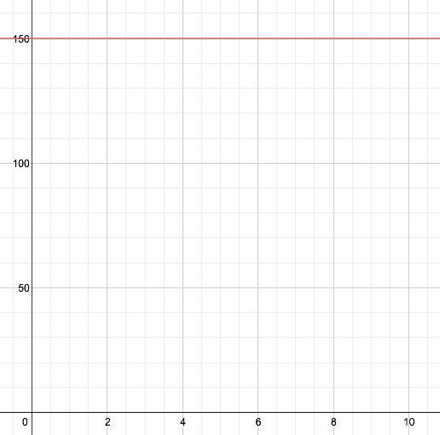
Graph:
Number of hours
Cost of Plumber in $

Initial Value: ______

R. of Ch.:__________

Equation: _________

