Linear Relations Lesson #5

Which table shows a linear relation (graph would be a straight line)?
A
Number of Kilometers  k | Cost ($)  C
1 | 5
2 | 10
3 | 15
4 | 20

B
Number of hours  h | Distance (km)  D
0 | 90
1 | 200
2 | 280
3 | 340
C
Number of days  d | Height of Plant (mm)  H
0 | 0
2 | 4
4 | 8
6 | 12

D
Number of Weeks  w | Bank Balance  B
0 | 140
1 | 100
2 | 60
3 | 20

What is the initial value for each table?
A: _________ B: _________ C: __________ D: ___________

Why is table C different than the other tables? _______________

What is the rate of change for the following table?

A: _____________ B: ________________ D: ________________

Why is finding the rate of change for C different than the others?

_________________________________________________________________

Which rates of change are positive? _________ Why are they positive? _________________________________________________

Which rates of change are negative? ___________ Why are they negative? __________________________________________________
Graph the three linear relations.

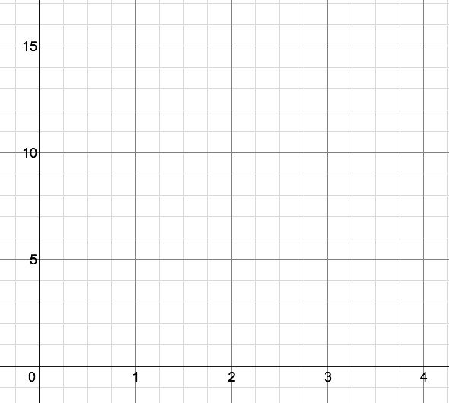

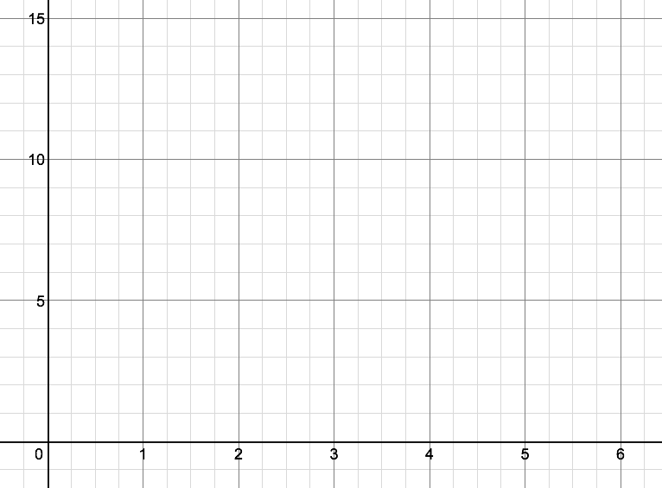

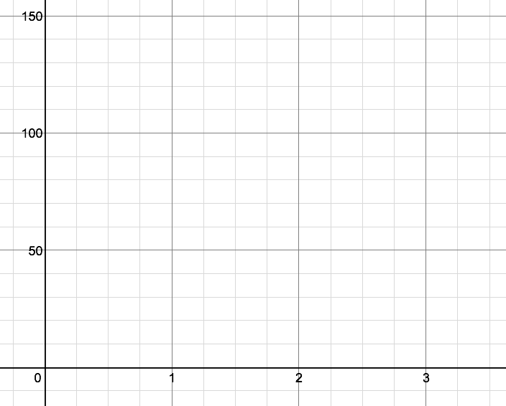

What is true about the graph of a relationship with a positive rate of change? ________________________________________

What is true about the graph of a relationship with a negative rate of change? _______________________________________

Direct Variation vs. Partial Variation

Direct Variation is when the graph goes through (0,0).

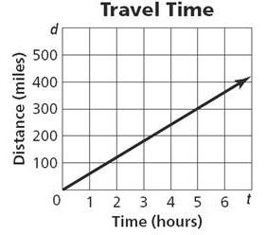
Partial Variation is when the graph does not go through (0,0).
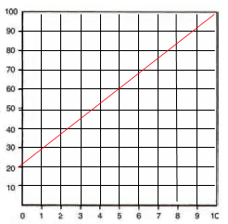
Which of the three linear relations above have direct variation? ________

Which of the three linear relations above have partial variation? _______

