Fraction | Fraction Circle | Fraction Circle | Fraction in 16ths | Image on a Ruler
1/16 | 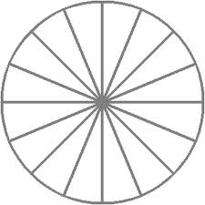
1/2
1/4
1/8

