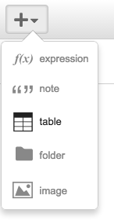
Graphing with Desmos - GO TO DESMOS.COM
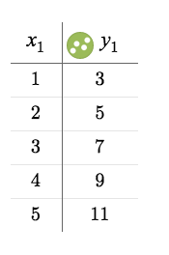
FIND THE + AND CLICK ON TABLE
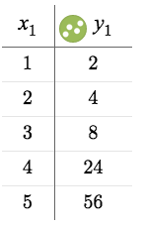
ENTER THE TABLES AND DRAW THE GRAPH BELOW

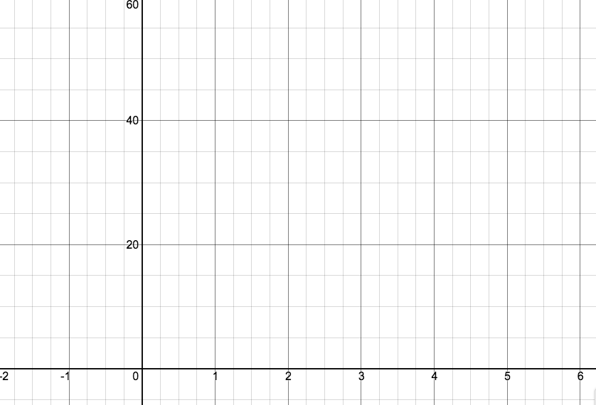

Which of the graphs is linear?

Which is non-linear?

How can you tell it is linear or non-linear from looking at the tables?

