GEOMETRY PROBLEMS

LEVEL 2:

1. On the map below, First Avenue and Second Avenue are parallel. What is the value of x?

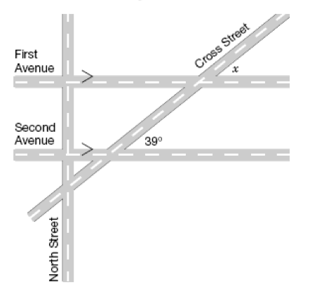

2. Determine the value of x in the triangle.

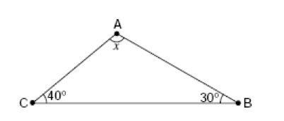

LEVEL 3:

1. Determine the value of x in the diagram?

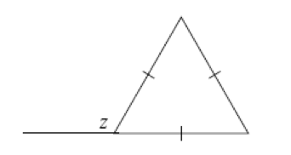

2. Consider the diagram below. Determine the value of x?
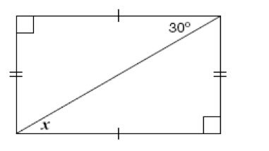

LEVEL 4

- Determine the value of x.
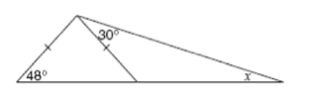

2. Determine the value of x.
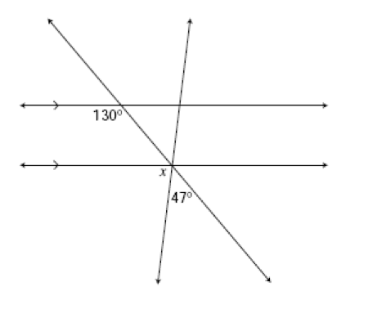

3. Determine the value of x.
