EQAO REVIEW #4
1.
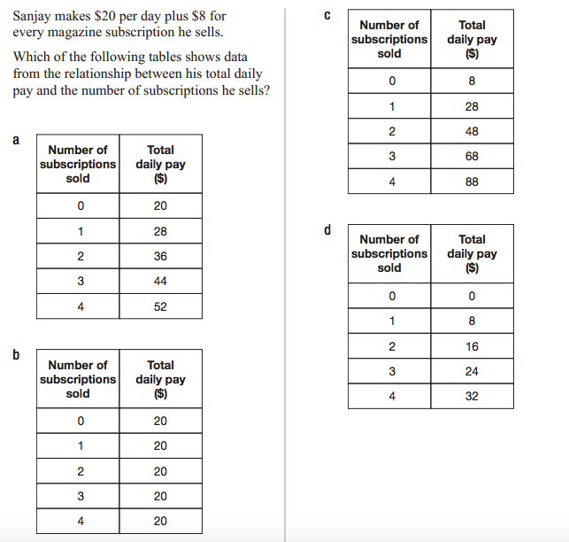

2. What is the initial value? What is the rate of change? What is an equation that represents his daily pay?

3. Graph Sanjay’s pay.

4. Mir makes more money for one day’s work but less money per subscription he sells. Graph a line for Mir on the same grid. Label the two lines: Sanjay and Mir.

5. Which company pays better?
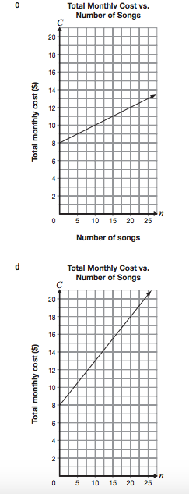
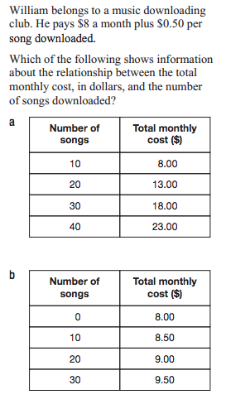
1.

2. Make an equation for William’s costs and
complete the table below.
Number of Songs | Total Monthly Cost ($)
0
5
10
15
3. Make a graph to represent William’s monthly cost.

4. Kalley joins another music club. Her monthly fee is less and her cost per song is higher. Sketch a line for Kalley on the same graph.

5. Which company is the better deal?
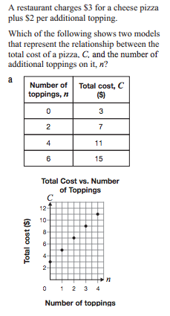
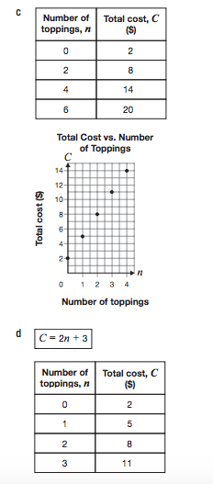
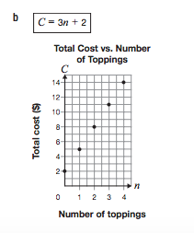
1.

2. What is the initial value and the rate of change of a)
What is an equation for a)
What is a sentence that describes the cost for a pizza a)
3. Make a table of values for b)
What is the initial value?
What is the rate of change?
4. What is the initial value and the rate of change of c)
What is an equation for c)
What is a sentence that describes the cost for a pizza c)
5. Make an equation for a company that has a higher initial value but a lower rate of change. Write a sentence to describe the cost of pizza at this company.
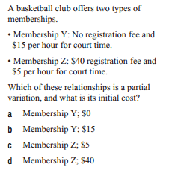
1.
2. Make a graph for the Membership that is direct variation.

3. On the same grid, make a graph for the Membership that is partial variation.

4. Make a equation for both memberships.

5. Which membership is the better deal?

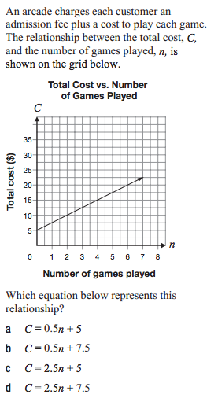
1.
2. Make a table of values for the graph above.

3. A second company charges a membership fee of $10 plus $2.50 per game.
What is the cost equation for this company?
How much would it cost to play 20 games?
How many games could you play for $75?

4. Make a table of values for the company from #3

5. Graph both companies of one grid. Which is the better deal?

