EQAO REVIEW #3

ALGEBRA AND NUMBER SENSE
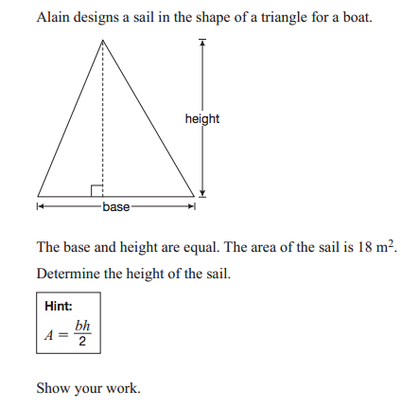

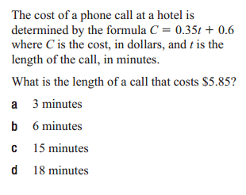

Simplify

$$3x^{2}+2x-4+5x-x-5x^{2}$$

PROPORTIONAL REASONING 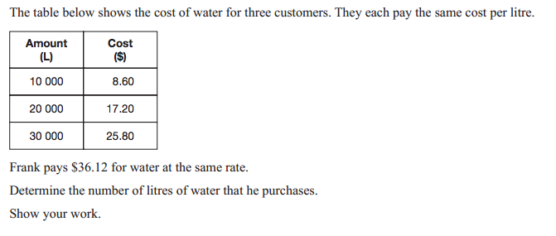
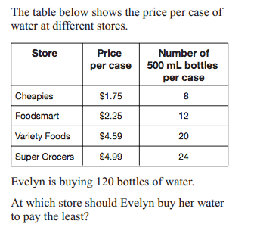

GEOMETRY

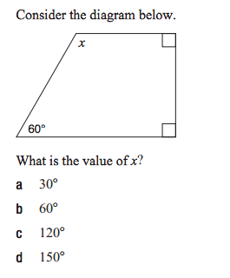
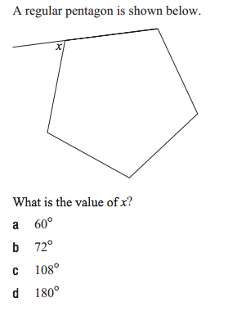

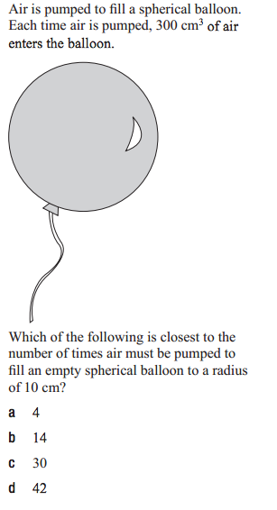
MEASUREMENT:
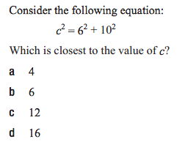
Draw a sketch to show how this equation could be used.

RELATIONSHIPS
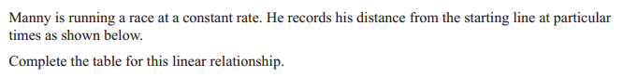

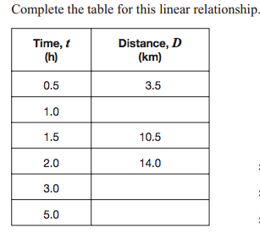
Determine the initial value.

Determine the rate of change.

Determine the equation.
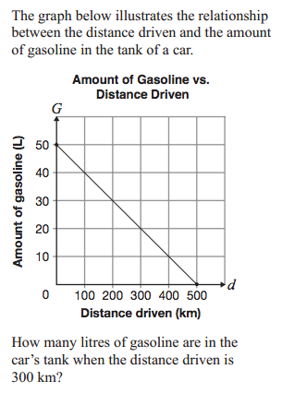

ALGEBRA AND NUMBER SENSE

GEOMETRY

MEASUREMENT:
Draw a sketch to show how this equation could be used.

RELATIONSHIPS

Determine the initial value.

Determine the rate of change.

Determine the equation.

Simplify

$$3x^{2}+2x-4+5x-x-5x^{2}$$

