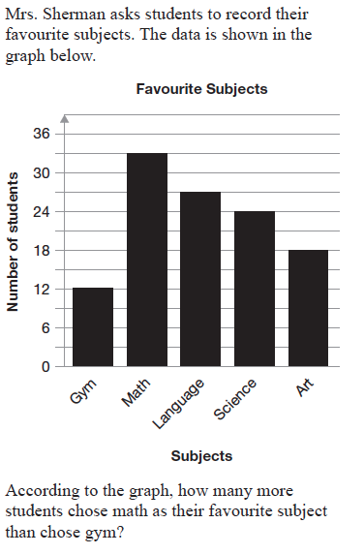
List some important features of this graph.

1.

2.

3.

4.

5.
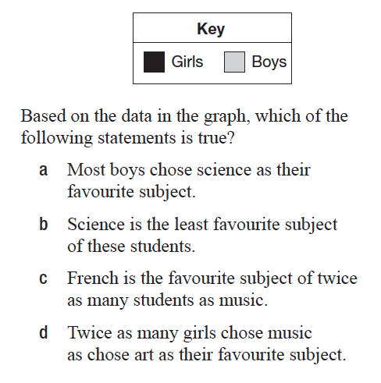
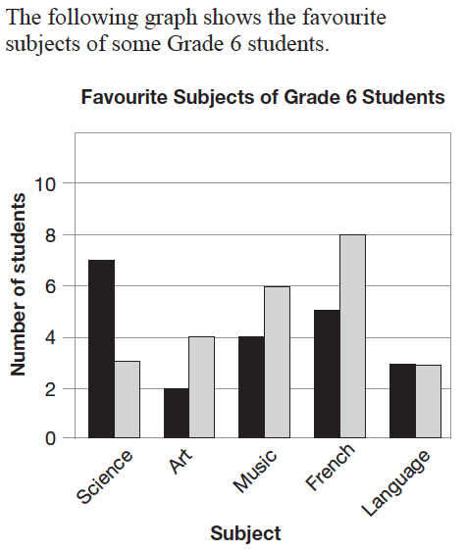
List some important features of this graph.

1.

2.

3.

4.

5.

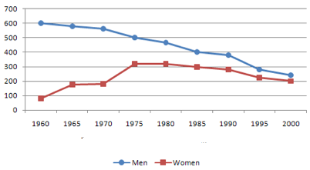
This is a line graph.
What three things is the line graph missing?
1. ____________________________
2. ____________________________
3. _____________________________
Are the numbers for the men and women increasing or decreasing? _________________________

When are the numbers for the men and women about equal? __________________________

What is the number for the men in 1975? _____________________What is the number for the women in 1960? ________________________

Is it true that the numbers for the men is triple the number for the women in 1960? ___________

Two bathtubs are being filled with water. The following table shows the heights of the water in the bathtubs at 4 different times.

Time | Height (cm)
 | Bathtub A | Bathtub B
8:00 | 2 | 1
8:01 | 4 | 2
8:02 | 7 | 4
8:03 | 9 | 8

