7.5,7.6
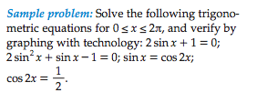
For all problems below, solve for x between 0 and 2$π$

2sinx = -1
sinx = -1/2

There should be two answers….
Check that they are reasonable given the graph of f(x) = 2sinx + 1 below.

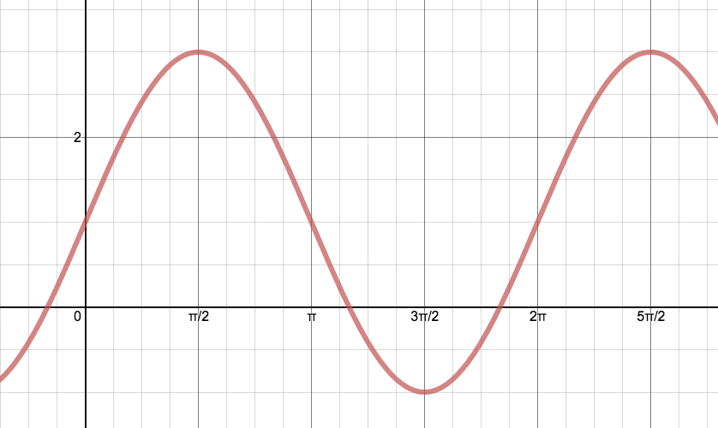

$$2\sin^{2}x + sinx- 1 = 0$$
$${2y}^{2}+y+1=0$$

Use Quadratic Formula to solve for y: $y=\frac{-1±\sqrt{1-4(2)(-1)}}{2(2)}$
$$y=\frac{-1±3}{4}$$
$$y=-1 or 0.5$$

NOW REMEMBER THAT $y = sinx$ and solve for x.

$sinx = -1$ $sinx = 0.5$ There should be 4 answers….

$$sinx = cos(2x)$$
Make the arguments the same…

$cos\left(2x\right)=1- \sin^{2}x$

Then move everything to one side to make it a quadratic equation that equals 0 so that you can use quadratic formula as you did in the question above.

As you can see by the graph there should be 3 answers between 0 and 2pi

$$cos2x= \frac{1}{2}$$

Hint: Let $θ=2x$
$$cosθ=\frac{1}{2}$$

There should be 2 answers for $θ$and then sub back in the $2x$ so that you can solve for $x$. You might need to add the period to find all the values of x between 0 and 2pi. As you can see from the graph there should be 4 answers.
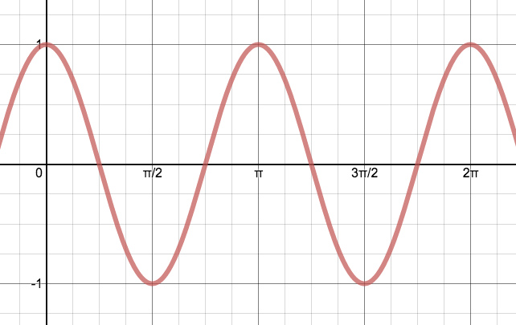

Now you try…

$$-3sinx – 1 = 1$$

$$sin2x = \frac{1}{\sqrt{2}}$$

$$sin 4x = \frac{1}{2}$$

$$sin2x = 2sinxcosx$$

$$6\cos^{2}x – cosx - 1 = 0$$

SOLUTIONS:

