5.3 – Graphs of Rational Functions with Holes

Graph the following.

$$y= \frac{24}{12}$$

Graph the following.

$$x= \frac{-36}{9}$$

Graph the following.

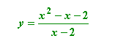

Graph the following.

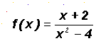

Graph the following

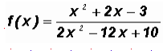

Graph the following

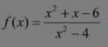

Determine the equation of the function.

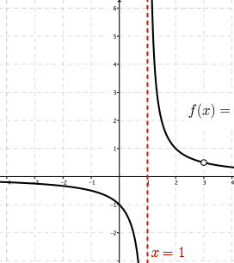

Determine the equation of the function.
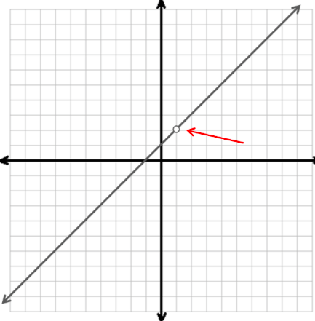

Determine the equation of the function.

