Sums and Differences of Cubes

Sums of Cubes

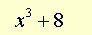 = 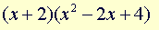

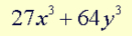 = (3x + 8y) (9x² – 24xy + 64y²)

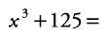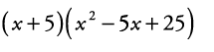
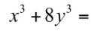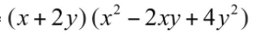
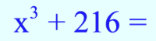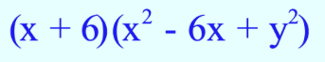

Differences of Cubes

=   