**Chapter 3 – Review of Polynomial Functions**

* identify and describe some key features of polynomial functions, and make connections between the numeric, graphical, and algebraic representations of polynomial functions
* Solve problems involving polynomial and simple rational equations graphically and algebraically;

1. Give an example of a function that is a polynomial function and one that is not a polynomial function.
2. What is the most number of zeros the function y=-4x5 + 3x2 + 1 can have? (Making a sketch may help to justify your answer)
3. Look at the table and determine the degree of the polynomial function.

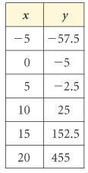

1. Determine the end behaviour of f(x) = -x3 + 25x.
2. Determine the average rate of change of f(x) between x=0 and x=1 in more than one way. Explain why the two answers are not identical.
3. Determine the instantaneous rate of change of f(x) at x=1 in more than one way. Explain why the two answers are not identical.
4. Determine the domain and range of y = . Determine the maximum number of turning points. Determine the maximum number of zeros.



1. Compare the two functions: f(x) = (x – 2)(x – 2)(x – 3) and f(x) = (x – 2)(x – 2)(x – 2)(x – 3)

(Compare means, what is the same and what is different. Sketching will help)

1. Consider the function y=-4(2(x-1))3 +1.
2. Describe the transformations. d) Determine the x-intercepts
3. Determine the end behaviours e) Sketch
4. Determine the y-intercept.

1. Determine an equation for a fifth-degree polynomial function that intersects the x-axis at only 5, 1, and –5, and sketch the graph of the function.
2. Determine the function in the family of polynomial functions of degree 3 with zeros 5, –3, and –2 that passes through (–1, 24)
3. Determine if f(x) = x3 -2x2 + 4 is even, odd or neither.
4. Determine the equation for the tangent line of f(x) at x = 0.
5. What is the remainder when we divide f(x) = x4 + 4x3 – x2 – 16x – 14 by x – 1
6. Factor: x3 + 2x2 – x – 2
7. Factor: x4 – 6x3 + 4x2 + 6x – 5.
8. What are the x-intercepts of the graph of f(x) = x4 – 13x2 + 36. Sketch f(x).
9. Determining the values of k for which the function f(x) = x3 + 3x2 + kx – 4 if the remainder when f(x) is divided by (x+3) is 14.
10. Consider the speed vs. time graph.

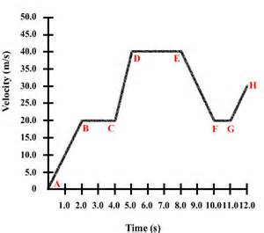

Sketch a distance vs. time graph that corresponds with it.

1. Consider the distance vs. time graph.

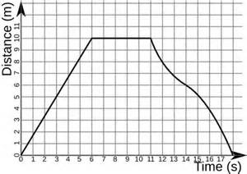

Sketch a speed vs. time graph that corresponds.