Chapter 1 – Graphing Assignment

Find a partner and complete the following. You will hand it in on Monday. I suggest you graph each with an online graphing program like fooplot.com or desmos.com to check your work!
For the following 4 functions,

- List all of the transformations.
- Create a parent table and transformed table.
- Make a graph.
- State the Domain and Range.
- State the Intervals of Increase/Decrease.
- State the End Behaviours.
- State the equations of the asymptotes if applicable.

a) $f\left(x\right)= \frac{1}{x} , y =6 f\left(-\left(x+1\right)\right)-4$ | b) $y= -\sqrt{-0.5\left(x-3\right)}+4$
c) $g\left(x\right)= \left|x\right| , y =0.5 g\left(2x\right)+3$ | d) $y=6\sin\left(-45\left(x+2\right)\right)-3$

- $f\left(x\right)= \frac{1}{x} , y =6 f\left(-\left(x+1\right)\right)-4$
vertically stretched by factor 3
reflected in the y-axis
translated left 1 unit
translated down 4 units
$D: \{\left\{x∈R | x≠-1\right\}$ $R: \{\left\{y∈R | y≠-4\right\}$
Interval of Increase $\left(-∞,-1\right), (-1, ∞)$
End Behaviours $as x→∞, y→-4, as x→-∞, y→-4, as x→{-1}^{-}, y→∞, as x→ {-1}^{+}, y→-∞$
Asymptotes x=-1, y = -4

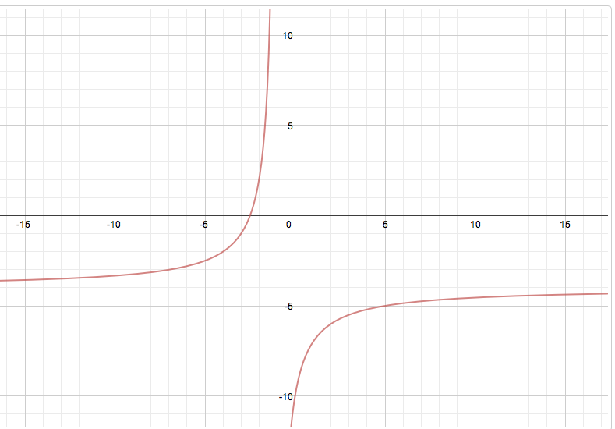

- $y= -\sqrt{-0.5\left(x-3\right)}+4$
horizontally stretched by factor 2
reflected in the x and the y-axis
translated right 3 units
translated up 4 units
$D: \{\left\{x∈R | x≤3\right\}$ $R: \{\left\{y∈R | y≤4\right\}$
Interval of Increase $(-∞,3)$
End Behaviours $as x→-∞, y→-∞$

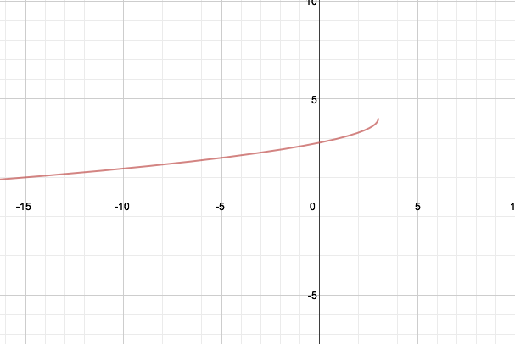

- $g\left(x\right)= \left|x\right| , y =0.5 g\left(2x\right)+3$
vertically compressed by factor 0.5
horizontally compressed by factor 0.5
translated up 3 units
$D: \{x∈R\}$ $R: \{\left\{y∈R | y≥3\right\}$
Interval of Increase $\left(0,∞\right)$ ; Intervals of Decrease $(-∞,0)$
End Behaviours $as x→∞, y→∞, as x→-∞, y→∞$
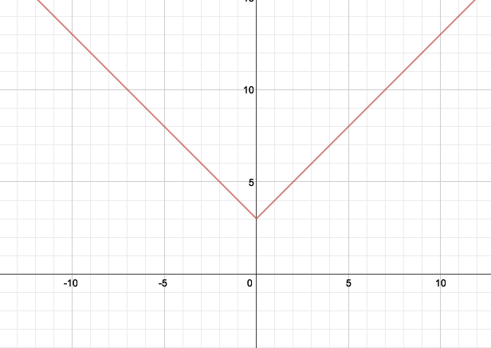

d) $y=6\sin\left(-45\left(x+2\right)\right)-3$
vertically stretched by factor 6
reflected in the y-axis
horizontally compressed by factor 1/45
translated left 2 unit
translated down 3 units
$D: \{x∈R\}$ $R: \{\left\{y∈R | -9≤y≤3\right\}$
Interval of Increase …(-8,-4) , (0,4) , (8,12)… (0+4n, 4+4n), where $n∈I$
Intervals of Decrease …(-4,0), (4,8), (12,16) … (4 + 4n, 8+ 4n), where $n∈I$
End Behaviours $:none as it is oscillating$

