MHF4U – 9.2-9.5 Review
1. Graph
- f(x) = 2^{–x} sin (4x)
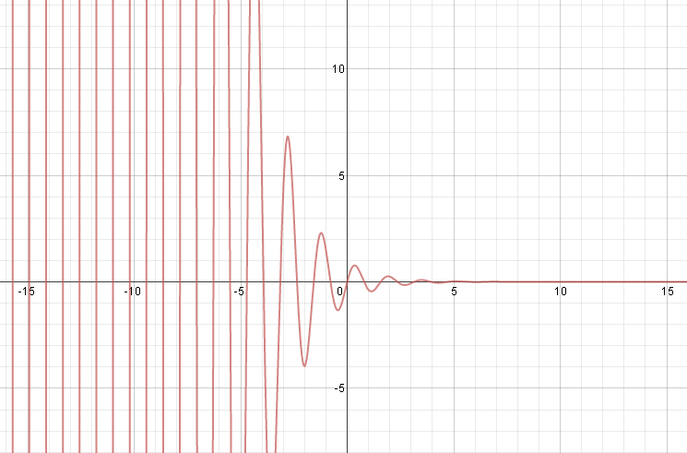

- g(x) = x² + 2^{x}
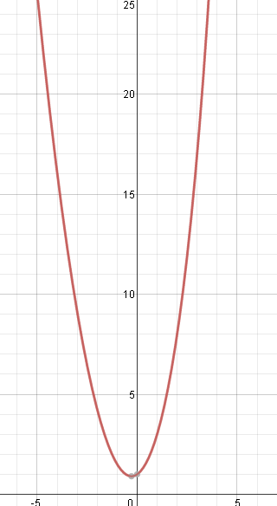
- h(x) = sinx/cosx
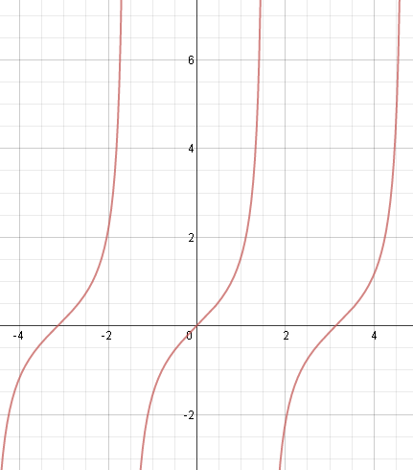

2. State the domain and range and number of zeros, asymptotes for the functions from #1.
a) D: x an element of the Reals
R: y an element of the Reals

b) D: x an element of the Reals
R: could only approximate…. y bigger than 0.9.

c) D: x an element of the Reals, except x cannot equal nx/2 where n is an odd integer.
R: y an element of the Reals.

3. For a car traveling at a constant speed, the distance driven, d kilometers, is represented by d(t) = 80t, where t is the time in hours. The cost of gasoline, in dollars, for the drive is represented by C(d(t)) = 0.09(d(t)).

a) Determine numerically and interpret C(d(5)).

The cost for gas for 5 hours of driving.

b) Describe the relationship represented by C(d(t)).

Linear – C(d(t) ) = 0.09 x 80t = 7.2t - with slope 7.2 and going through (0,0). This means the cost for driving 0 hours is $0 and the cost increases 7.2$ per hour driven.

4. Given f(x) = cosx and g(x) = 2x + 1.
a) Determine f(g(x)) and g(f(x))
f(g(x)) = cos(2x+1) g(f(x)) = 2cosx + 1
b) State the domain and range of f(g(x)) and g(f(x)),
f(g(x)) : D = x in the reals; R= y between -1 and 1.
g(f(x)) : D = x in the reals; R = y between -1 and 3

c) Compare the graphs of both. Are they the same?
They are not the same. Graph to show this is true.

5. Demonstrate with an example that f⁻¹(f(x)) = x and f(f⁻¹(x)) = x

f(x) = 2x -7 f⁻¹(x) = (x+7)/2
f(f⁻¹(x)) = 2((x+7)/2) – 7 = x+7 -7 = x

f⁻¹(f(x))= ((2x-7) +7)/2 = 2x/2 = x

6. The rate at which a contaminant leaves a storm sewer and enters a lake measured in kilograms per second depends on two factors: the concentration of the contaminant in the water from the sewer and the rate at which the water leaves the sewer. Both of these factors vary with time. The concentration of the contaminant, in kilograms per cubic metre of water, is given by c(t) = t², where t is in seconds. The rate at which the water leaves the sewer, in cubic metres per second is given by w(t) = 1/(t⁴ +10). Determine the time at which the contaminant leaves the sewer and enters the lake that the maximum rate. (Look at the units to determine whether you should add, subtract, multiply or divide c(t) and w(t) )

$$\frac{Kg}{m^{3}} ×\frac{m^{3}}{s}=kg/s$$
This means we must multiply the two equations.
$$f\left(t\right)= c\left(t\right)×w\left(t\right)= t^{2}×\frac{1}{t^{4}+10}=\frac{t^{2}}{t^{4}+10}$$
Graph f(t) by graphing c(t) and w(t) and then taking the quotient. Then you can find the maximum.
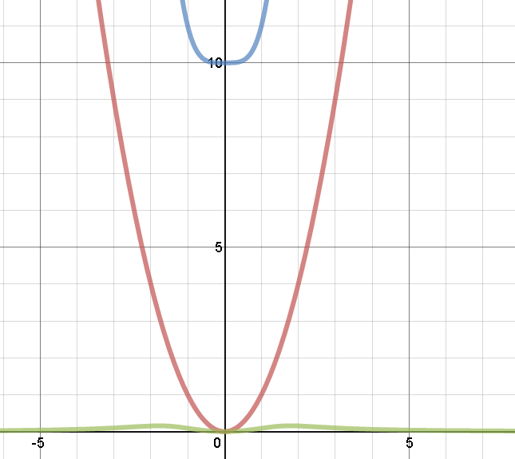
Clearly, the max seems to happen a bit before 2 hours.

