7.2 Compound Angles
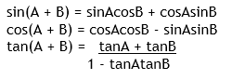
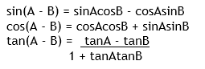

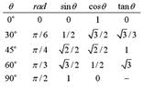
Example 1: Find the exact value of $Sin (19 π/ 12)$.
Sin (285) = sin (240 +45)
$$Sin (19 π/ 12) = Sin (4π/3 +π/4)$$

Example 2: Evaluate $sin (a + b)$ where $a$ and $b$ are obtuse angles;$sin a =\frac{4}{5}$ and $\sin{b=\frac{6}{7}}$.

Example 3: Use compound angle formulas to show that $sinx = -sin\left(2π-x\right)$

Homework: pg 401 #9, 10, 11

7.3 – Double Angle Formulas
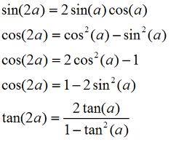
Example 1: Simplify $2sin\frac{π}{12}cos\frac{π}{12}$

Example 2: If $cosθ= -\frac{3}{5}$ and $0≤θ≤2π$, determine the value of $cos2θ$ and $sin2θ$.

Example 3: Given that $tanθ= -\frac{5}{7},$ where $\frac{3π}{2}≤θ≤2π$, determine the value of $cos2θ$ .

Example 4: Develop a formula for $sin\frac{x}{2}$ in terms of $x$.

Homework: pg 407 #4-10, 13

