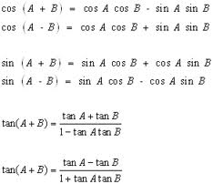
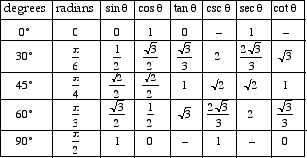
7.2:
Compound Angle Formulas

- 3.2 explore the algebraic development of the compound angle formulas (e.g., verify the formulas in numerical examples, using technology; follow a demonstration of the algebraic development [student reproduction of the development of the general case is not required]), and use the formulas to determine exact values of trigonometric ratios [e.g., determining the exact value of sin ([pi]/12) by first rewriting it in terms of special angles as sin ([pi]/4 – [pi]/6)]

Special angles that we know the exact value for: Write with a common denominator to make working with them easier.

$π$/6, $π$/4, $π$/3, $π$/2, $π$, 2$π$ _____ , ______, _______, _______, ________, _____

Then find all other related special angles.

0 ° | 30° | 45° | 60° | 90° |  |  |  | 180° |  |  |  | 270° |  |  |  | 360°

Example 1: Find the exact value of sin 75˚ Find the exact value of sin(5$π$/12)

Example 2: Find the exact value of cos 15˚ Find the exact value of cos($π$/12)

Example 3: Find the exact value of tan(-15˚) Find the exact value of tan(-$π$/12)

Example 4: Find the exact value of $Sin (19 π/ 12)$.
Sin (285°)= sin (240° + 45°)
$$Sin (19 π/ 12) = Sin (4π/3 +π/4)$$

Example 5: Evaluate $sin (a + b)$ where $a$ and $b$ are obtuse angles;$sin a =\frac{4}{5}$ and $\sin{b=\frac{6}{7}}$

Example 6: Use compound angle formulas to show that $sinx = -sin\left(2π-x\right)$

Example 7: Simplify cos(5 $π$/12)cos($π$/12)+sin(5 $π$/12)sin($π$/12)

