Section 7.1 – Equivalent Trigonometric Expressions

- 3.1 recognize equivalent trigonometric expressions [e.g., by using the angles in a right triangle to recognize that sin x and cos ([pi]/2 – x) are equivalent; by using transformations to recognize that cos (x + [pi]/2 ) and –sin x are equivalent], and verify equivalence using graphing technology
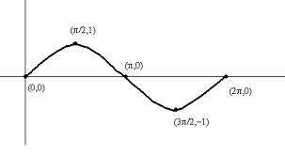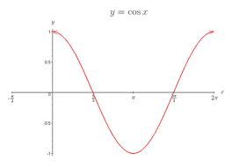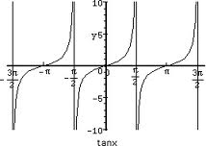
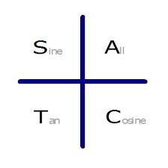
sin (x) = sin ( )
= cos ( )

cos (x) = cos ( )
= sin ( )

tan (x) = tan ( )

Example 1: State two trig ratios that are equivalent to each of the following.

a) Sin 3$π$/10 b) -cos 8$π$/7

You try:
a) -sin13$π$/7 b) cos6$π$/7

Example 2: Write an equation that is equivalent to y= - 5sin(x-$π$/2) – 8.

Homework: pg 392 - #5,7

