6.6 Modelling the Illumination of the Moon in January

https://www.youtube.com/watch?v=yLz48vxdjS8

Day | 1 | 4 | 11 | 16 | 19 | 22 | 27 | 29 | 31
Illumination | 0.00 | 0.11 | 0.79 | 1.00 | 0.92 | 0.70 | 0.19 | 0.05 | 0.00

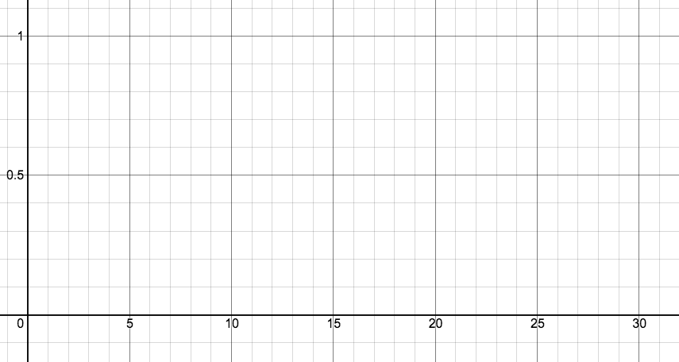

Determine when the Moon is at 0.29 illumination.

