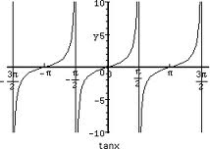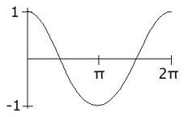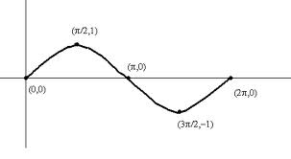
6.4 - Transforming y= sinθ, y= cosθ, and y= tanθ

θ | y= sinθ
0
π/2
π
3π/2
2π
Domain:
Range:
Period:
Amplitude:
θ | y= cosθ  Domain:  Range:  Period:  Amplitude:
0
π/2
π
3π/2
2π

θ | y= tanθ  Domain:  Range:  Period:  Amplitude:
-π/2 | Undefined
-π/4
0
π/4
π/2 | Undefined

Example 1: Consider f(x)= 3sin2θ + 1
- Make a table for f(x).
θ | f(x)
Domain:
Range:
Period:
Amplitude:

- Fill in the text box for f(x).

Example 2: Make a table for y= -2tan(0.5θ)
- Make a table for f(x).
Θ | f(x)
Domain:
Range:
Period:
Amplitude:

- Fill in the text box for f(x).

Example 3: Graph y = sin (2(x+π/6)) – 1

- Determine the axis of symmetry. Plot it.



- Determine the amplitude. Mark the peak and the trough on the graph above.
- Determine if the graph starts at the top, middle, or bottom. Mark the starting point on the graph above.
- Determine the period. (Period = 2π/k)

- Divide the period in 4 – to find the 4 important points on the graph and mark these points on the x-axis.

- Draw the graph.
- Make the table to check that your graph is correct.

Θ | f(x)  Check your answer on page 339
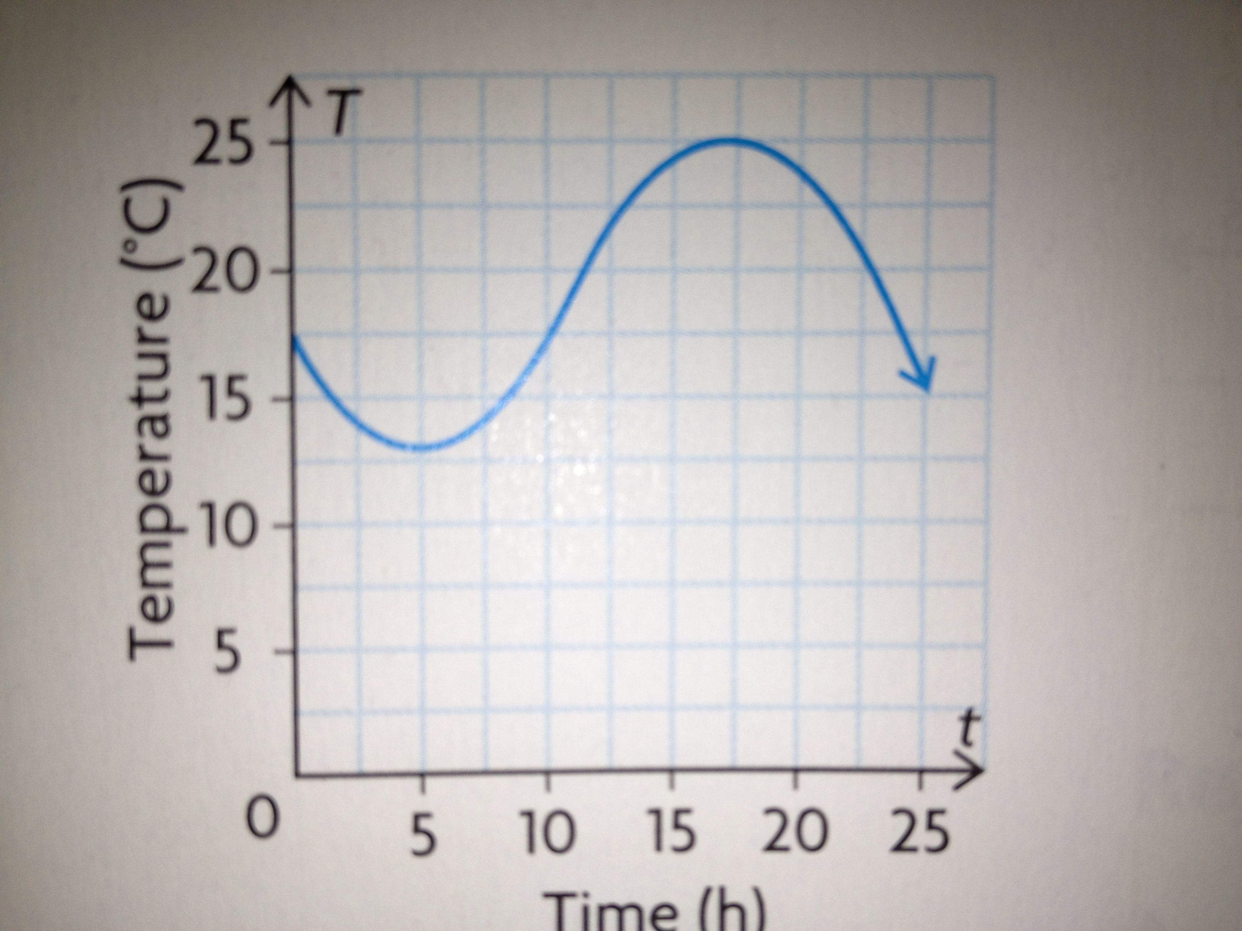
Example 4: Determine the equation of the following graph.

Step 1: Determine the period.
Step 2: Find “k” by using the formula: Period = 2π/k
Step 3: Find “c” by identifying the centre of the graph
(the middle between the peak and the trough)
Step 4: Find “a” finding the difference between the top and the
centre.
Step 5: Determine if it is a cosine curve or sine curve (sin curve
starts in the middle, cosine curve starts at the top or bottom)
Step 6: Determine if it is +ve or –ve (negative if starts in the middle
and goes down or negative if starts at the bottom rather than the top)
Step 7: Write the equation.
Check your answer on page 342

Homework: #8c and f and #14 and #9

