6.2 – Radians and Special Angles: Independent Study
Read 6.2 in your textbook, complete this handout, and complete the homework questions by Wednesday.

Express all the important angles below in radians and complete the table at the bottom of the page.
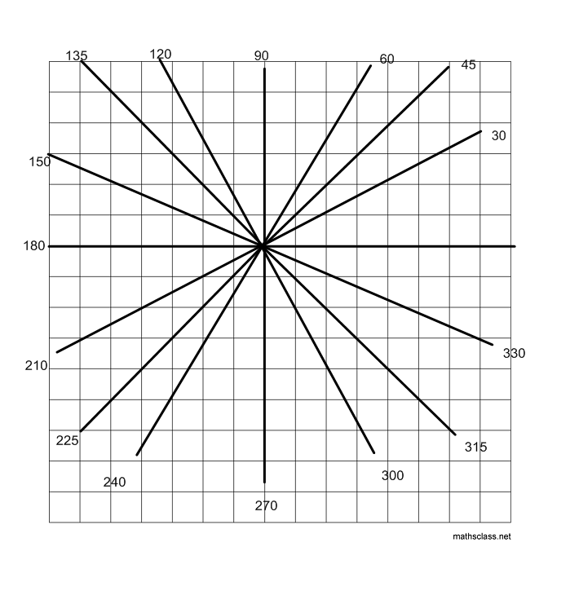

 | Special Angles
Degrees | 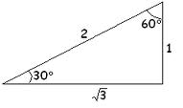 | 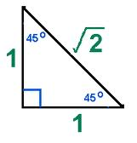
Radians | Draw the diagrams with the angles in radians | Draw the diagrams with the angles in radians

RECALL: 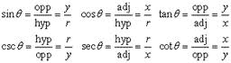
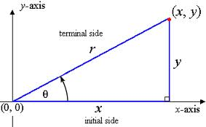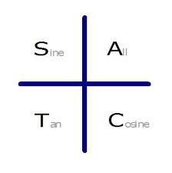
r² = x² + y²

Complete the trigonometric ratio table for the 3 special angles.

$$θ$$ | $θ$/4 | $θ$/6 | $θ$/3
Sin($θ$)
Cos($θ$ )
Tan($θ$)
Csc($θ$)
Sec($θ$)
Cot($θ$)

Example 1: Find the angle in radians of the angle whose terminal arm ends at (4,3).

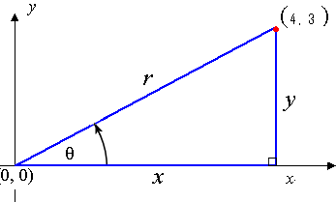
Since you have x and y, use tan$θ$ = y/x
tan$θ$ = ¾
MAKE SURE YOUR CALCULATOR IS IN RADIANS
$θ$ = tan⁻¹ ¾
$θ$ = .6435 radians
You try: Find the angle in radians of the angle whose terminal arm ends at (3,7) (Ans: 1.17)

Example 2: Determine sin (3$π$ /2).

Sketch where 3$π$ /2 is on the Cartesian plane.

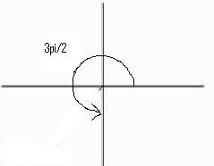
Pick ANY point on the terminal arm. E.g (0, -2) is on the terminal arm.

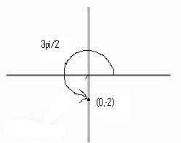
Recall sin (3$π$ /2) = y/r , so you must find r using r² = x² + y²

r² = 0² + (-2)²
= 0 + 4
= 4
r = 4 ^{½}
= 2

Use the formula sin (3$π$ /2) = y/r
sin (3$π$ /2) = -2/2 = -1 (you can now check with your calculator that sin (3$π$/2) = -1)

You try: Determine the exact value of cot ($π$ /2)
(The answer should be 0)

Example 3: Determine the exact value of sin 4$π$ /3.

Sketch the angle in standard position.

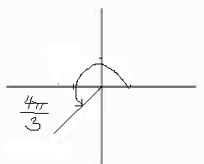
Related Acute Angle

In Q2 θr= π – θ
In Q3 θr = θ – π
In Q4 θr= 2 π – θ

=

Determine the related acute angle since we are not in quadrant 1.

Related Acute Angle = 4$π$ /3 – $π$
= $π$/3

Change the question to involve the related acute angle sin $π$ /3
Sin $π$ /3 = √3 / 2 (USE THE CHART ABOVE)

Use CAST rule to determine if the answer should be positive or negative.

Sin 4$π$ /3 = - √3 / 2 since in Q3, sine is negative.

You TRY: Determine the exact value of cos (5$π$ /4) and csc(11$π$ /6) (CHECK SOLUTIONS ON PAGE 326)

Example 4: If cos$θ$ = - 6 /7, where $θ$ $ϵ$ [0,2$θ$], evaluate $θ$ to the nearest hundredth.

Draw the two possible locations of $θ$, remembering that cos is negative in 2 quadrants according to CAST. I have drawn one possibility. Can you draw the other?

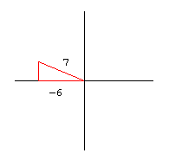
Ignore all negatives and imagine that the drawing was in Q1 where x and y would both be positive and find the related acute angle.

Calculate cos$θ$ r = 6/7
$θ$ r = 0.54

Above you found the related acute angle, find the actual angles in Q2 and Q3.
In Q2: $θ_{1}$ = π – θr
= 3.14 – 0.54 = 2.60
Related Acute Angle

In Q2 θ= π – θr
In Q3 θ = π + θr
In Q4 θ= 2 π – θr

=
In Q3: $θ_{2}$ = π + θr
= 3.14 + 0.54 = 3.68

You try: Solve for $θ$ if tan $θ$ = - 7/24

(Check your answers on page 328)

HOMEWORK: pg 330 #5-10 ; 13-16

