Radian Measure – 6.1

What is a radian?
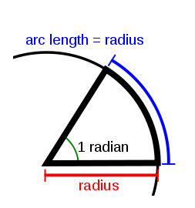
$$θ=\frac{a}{r}$$

How many radians are there in a whole circle?

6. 28 (______) radians = ________degrees

3.14 (_____) radians = ___________ degrees

Example 1: Convert the angle to radians
a) 25 degrees b) 190 degrees

Example 2: Convert the radian measure to degrees
a) $3π/4$ b) 1.25 radians

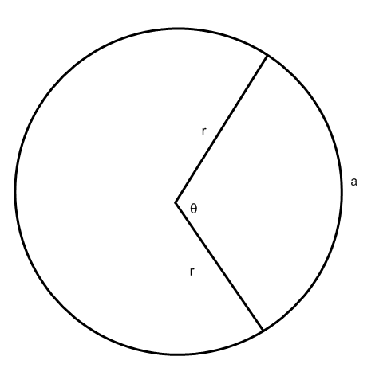
The radian is an alternative way to represent the size of an angle. The arc length, a, of a circle is proportional to its radius, r, and the central angle that it subtends, $θ$, by the formula $θ=\frac{a}{r}$ .

Example 3: If a= 6cm and r = 3.5 cm, determine the angle $θ$ in radians.

Example 4: The Ferris Wheel at Niagara Falls has a diameter of 150 m and completes one rotation in 6 minutes.
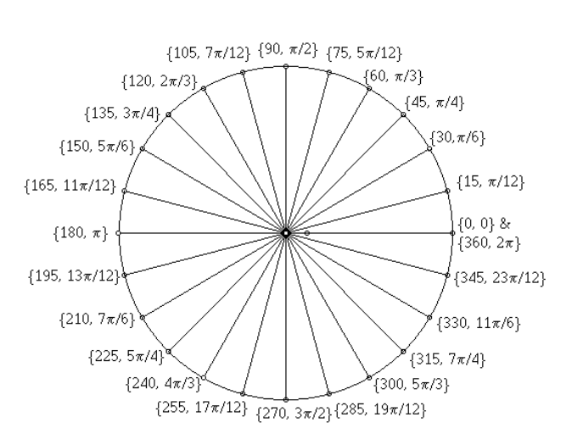
a) Determine the angular velocity, $ω$ , in radians per second. (notice radians per second NOT per minute)
b) How far has a rider traveled at 4 minutes into the ride?

