5.5 – Rational Inequalities
$$f(x) = \frac{\left(x+3\right)(x+1)}{\left(x-2\right)(x+4)}$$
Is f(-5)>0 or <0?
(x+3)
(x+1)
(x-2)
(x+4)
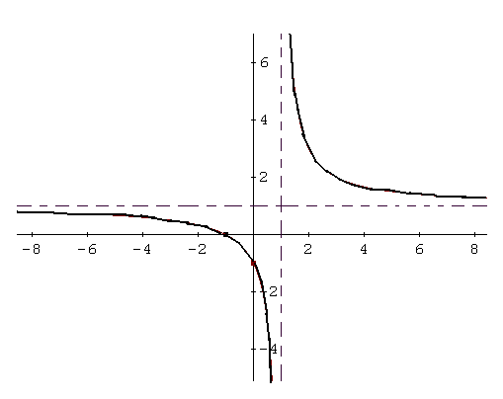
When is f(x)>0? What are key points on the graph to determine when f(x)>0 or f(x)<0?
Example 1: Solve. 5/(x-2) >0
 | x<2 | x>2
(x-2)
5/(x-2)

Example 2: Solve (3x+1)/(x-1) <0
 | x<-1/3 | -1/3<x<1 | x>1
3x+1
x-1
(3x+1)/(x-1)

Example 3: If f(x)= (2x+3)/(4x+20), determine when f(x)>0 without graphing

Example 4: Solve $x-3<\frac{4}{x}$
- Move all terms to the left hand side
- Find a common denominator
- Combine the terms
- Factor the numerator (to find the zeros)
- Determine when the denominator = 0 (to find the asymptotes)

Example 5: Solve $\frac{2x}{3x+4}>\frac{x}{x+1}$

- Move all terms to the left hand side
- Find a common denominator
- Combine the terms
- Factor the numerator
- Determine when the denominator =0.

