4.4 Rates of Change In Polynomial Functions
Average Rate of Change: $Average Rate of Change=\frac{f\left(x_{2}\right)- f(x_{1})}{x_{2}-x_{1}}$

Instantaneous Rate of Change: $M_{T}=\frac{f\left(x+h\right)-f(x)}{h}, as h→0$
Example 1: Determine the average rate of change from$x=0$ to $x=3$ on the function
$$f(x) = {(x-2)}^{3} +1$$
Method 1: Use one of the formulas above.

Method 2: Graph the function and draw the ___________ line, then calculate the slope of the _______________ line between $x=0$ and $x=3$ . (Notice it is just $y=x^{3}$ moved right 2 and up 1)

Example 2: The graph of a polynomial function is shown. Estimate the instantaneous rate of change of f(x) at the point (-1,0).
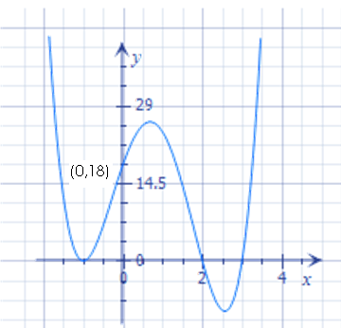
Method 1: Determine the equation of the above function so that you can use one of the formulas at the top of page one.
Step 1: Find the equation using factored form and then solving for a.

Step 2: Use a formula from page 1.

Method 2: Draw a _________________ line for the function at the point (___,____). Then calculate the _________ of the tangent line.

Example 3: Consider $f(x) = -4x^{2} + 1$. Find the equation of the tangent line at $x=2$.
Step 1: Sketch the function so that you have an idea of whether the slope of the tangent line should be positive or negative.

Step 2: Use the instantaneous rate of change formula (the difference quotient) to determine the instantaneous rate of change at x=2.

Step 3: The answer to step 2 will be the slope of the tangent line. Use the formula $y=mx +b$ and sub in the slope.

Step 4: Sub in the point (2, ___) to find the b.
Step 5: Write out the equation.

Example 4: Graph the function $y=x^{3}+2x^{2}-8x$and estimate where the instantaneous rate of change is positive, negative and zero.

Step 1: Factor to find zeros

Step 2: Graph

Step 3: Circle in pencil where the graph is increasing, circle in pen where it is decreasing and highlight where there is a local max or min.

Step 4: Determine the exact coordinates of the local max and local minimums by using the instantaneous rate of change formula and equating it to zero. (for a level 4 – otherwise just estimate)

Step 5: Write out the intervals.

