2.5 Solving Problems Involving Rates of Change
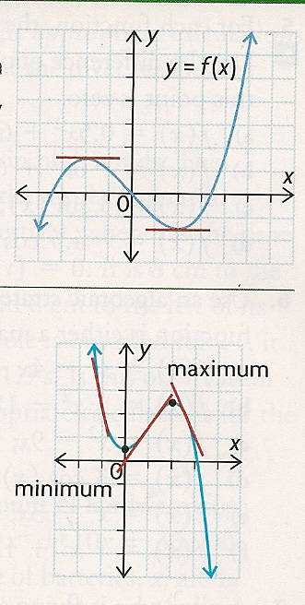
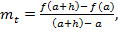
as

1. What is true about the instantaneous rate of change at a turning point?

2. What is true about the instantaneous rate of change immediately to the left of the maximum?

3. What is true about the instantaneous rate of change immediately to the right of the maximum?

4. What is true about the instantaneous rate of change immediately to the left of the minimum?

5. What is true about the instantaneous rate of change immediately to the right of the minimum?

Example 1: Muna is riding a Ferris wheel. Muna's elevation, h(t), in meters above the ground at time t in seconds, can be modelled by the function
. Abbas thinks that Muna will be closest to the ground at 55 s. Do you agree? Support your answer.

Example 2: Hamza has a culture of 50 bacteria that is growing at a rate of 10% per hour. He observed the culture for 12 hours. During this time period, when is the instantaneous rate of change the greatest?

Example 3: Show that there is a minimum for f(x) = x² - 10x + 7 is at x = 5 using the difference quotient.

Example 4: Show that there is a maximum for f(x) = -x² – 6x - 4 at x=-3 using the difference quotient.

Example 5: A pilot who is flying at an altitude of 10 000 feet is forced to eject from his airplane. The path that his ejection seat takes is modelled by the equation h(t) =-16t² +90t+10 000, where h(t) is his altitude in feet and t is the time since his ejection in seconds. Estimate at what time, t, the pilot is at a maximum altitude. Explain how the maximum altitude is related to the slope of the tangent line at certain points.

Homework: pg 111- 113: #1-4, #5bc, #6de, #8, #11

