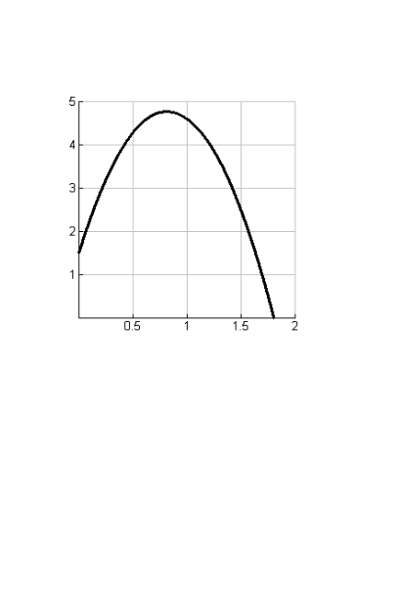
2.3: Tangent Slopes and Graph Characteristics
Homework: pg 86 #4, 5,7
1. Using the graphs below, estimate the instantaneous rates of change (m_{T}) for each of the graphs at the given points.

T | 0 | .25 | .5 | .8 | 1 | 1.5 | 1.8
M_{t}
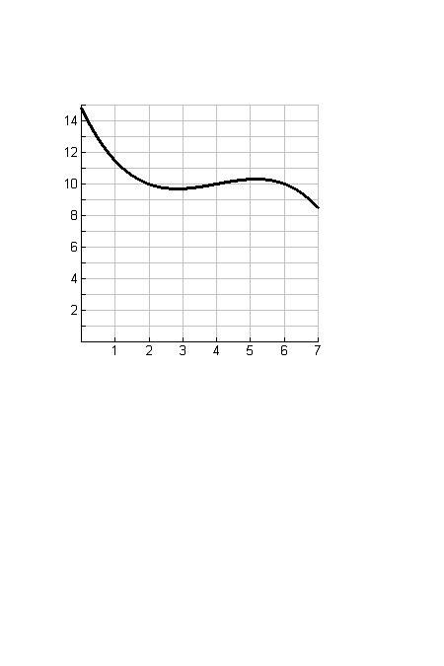

t | 0 | 1 | 2 | 3 | 4 | 5 | 6 | 7
M_{t}

2 a) Describe the graphical features (e.g., local maximum/minimum point, interval of increase/decrease), m_{T} values (e.g., +, -, 0), and, where appropriate, the trend of the slope of the tangent (e.g., changing from positive to zero to negative) as time increases.
Interval | Graphical feature  (local max/min point, interval of increase, interval of decrease) | mT values  (+, - , 0) | mT trend (if appropriate)  (changing from positive to zero to negative  or  changing from negative to zero to positive)
Graph A: Domain 0-0.8
Graph A: at 0.8
Graph A: Domain 0.8-1.75
Graph B: Domain 0-3
Graph B: at 3
Graph B: Domain 3-5
Graph B: at 5
Graph B: Domain 5-7

b) Describe the context where the slope of the tangent is zero. What does it mean?

3. The slope of the secant line can be a good estimate of the slope of the tangent. Ali thought that using an interval of 1 second to determine the slope of the secant line in graph A is good enough to estimate the slope of the tangent. Do you agree or disagree? Justify your reasoning.

4. For Graph A, state the slope of the tangent at 0.5 and 1 second. At which point is the shot put going faster? Explain.

5. Rita says that a tangent crosses a curve in one and only one point. Do you agree or disagree? Use Graph B to justify your position.

Example: Finding the instantaneous rate of change using the DIFFERENCE QUOTIENT
$m_{t}=\frac{f\left(a+h\right)- f(a)}{h}$, as $h→0$
Consider the functions
- $f\left(x\right)= -2{(x-4)}^{2}+6$, find the instantaneous rate of change at x=2
- $f\left(x\right)= \frac{1}{2x+6}$, find instantaneous rate of change at x = 1
- $f\left(x\right)= \sqrt{x-3}$, find instantaneous rate of change at x = 5

