Exploring Operations with Functions - 1.7

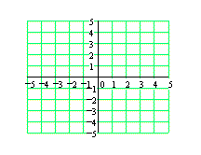
Example 1:
$$f = \{(-4,3), (-2,-4), (1,3), (3,8), (4,-1)\}$$
$$g = \{(-4,2), (-2,1) , (0,-1), (1,2) (2,-9) (4,4) \}$$

- Determine $f + g$

- Determine $fg$

Example 2: Use the graphs of$f$and $g$ to graph $f + g$
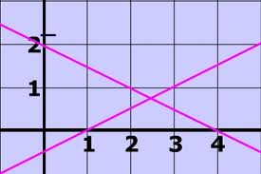
EXPLORING what this means in a real life situation

A popular coffee house sells iced cappuccino for $4 and hot cappuccino for $3. The manager would like to predict the relationship between the outside temperature and the total daily revenue from each type of cappuccino sold. The manager discovers that every 1 degree Celsius increase in temperature leads to an increase in the sales of cold drinks by three cups per day and to a decrease in sales of hot drinks by five cups per day.

The function f(x) =_______________
can be used to model the number
of iced caps sold.

The function g(x) = -5x +200
can be used to model the number
of hot caps sold.

In both functions, x represents the daily average outside _________________. In the first function, f(x) represents the daily average number of ______________ sold. In the second function, g(x) represents the daily average number of ____________sold.

a) Make a table of values for each function, with the temperature in intervals of 5 degrees. Then sketch f(x) and g(x) below.
X | f(x) | g(x)
0
5
10
15
20
25
30
35
40

b) What does h(x) = f(x) + g(x) represent?
c) Simplify h(x)
d) Make a table of values for the function, h(x). How do the values compare with the values in the table from A? How do the domains of f(x), g(x) and h(x) compare?
x | h(x)
0
5
10
15
20
25
30
35
40

e) What does R(x) = 4f(x) + 3g(x) represent?

f) Simplify R(x).

g) Make a table of values for the function, R(x). How do the values compare with the values in the tables from A? How do the domains of f(x), g(x) and R(x) compare?

x | R(x)
0
5
10
15
20
25
30
35
40
h) How does temperature affect the daily revenue from a cappuccinos sold?
HOMEWORK: pg 56-58: 1b,c; 2a; 3b; 4,5,6,7,8

