Section 1.4 - Transformations

RECALL: $y = a f[k(x-d)] + c$

a -vertical stretch/compression: _____________________
- reflection in ____-axis if negative

k - horizontal stretch/compression: ______________________
-reflection in ____-axis if negative
** We say there is a horizontal stretch/compression of 1/k ** (NEW FROM GRADE 11)

d - horizontal translation
- left if there is a _______ in the bracket – this means that d is ______________
- right if there is a _________ in the bracket – this means that d is ______________

c - vertical translation
- up if _____________
-down if _____________

TURNING POINT: ____________________________________________________________________________

____________________________________________________________________________________________
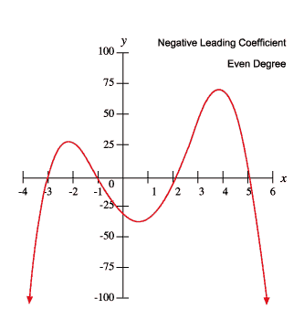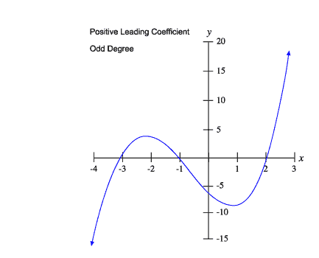
Example 1: State the function that would result from vertically stretching y=f(x) by a factor of 4 and horizontal stretching by a factor of 5 and then translating the graph 3 units to the left.

Example 2: Use transformations to help you describe the characteristics of the transformed function
$y = 0.5\sqrt{x-3}+5.$ Then sketch the transformed function.

Example 3: Graph the function f(x) = sin(x) and the transformed function $y = -4f\left(3x\right)+1$ where 0˚ ≤x≤360˚. State the impact of the transformations on the domain, range, and intervals of increase/decrease, and turning points of the transformed function.

Example 4:
Describe the order in which you would apply the transformations defined by $y= -2f[3(x+1)] -4$
to $f(x) = \sqrt{x}$ .

Then state the impact of the transformations on the domain, range, intervals of increase/decrease, and end behaviours of the transformed function.

Example 5: Describe the order in which you would apply the transformations defined by
$y= -2f[3(x+1)] -4$ to $f(x) = 2^{x}$ .

State the impact of the transformations on the domain, range, intervals of increase/decrease, and end behaviours of the transformed function.

State the equation of the transformed function.

