Section 1.3: Properties of Graphs and Functions

Definitions:

INTERVALS OF INCREASE - The interval(s) within a function's _______________, where the ____ values of the function get _______, moving from ______to ________

INTERVALS OF DECREASE - The interval(s) within a function's _____________, where the _____ values of the function get _________, moving from ______to _________
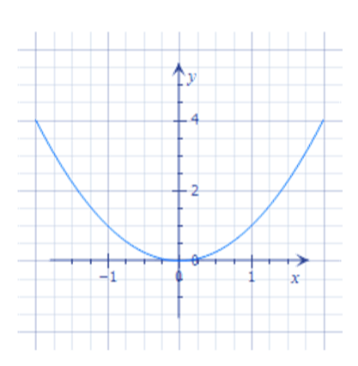
State the intervals of increase and decrease for the function on the left.
EVEN FUNCTION

Any function that is ______________ about the _____axis; algebraically all even functions have the property _____________________.
The function above is an example of an ________ function.
Draw another example of another even function.
What is the equation of the function above?
Show that f(-x) = f(x).
What do you get if you sub in x into the equation?

What do you get if you sub in –x into the equation?

Are they equal?

ODD FUNCTION
Any function that has the rotational symmetry about the origin; algebraically all odd functions have the property ______________.
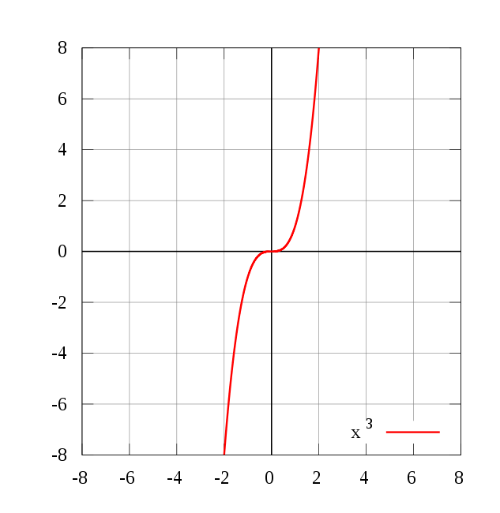
What is the equation of the function of the left?

Show that f(-x) = -f(x)
Let x= 2
Calculate f(-x) Calculate – f(x)
Are they equal?

CONTINUOUS FUNCTION
Any function that does not contain any __________ or ________over its entire domain
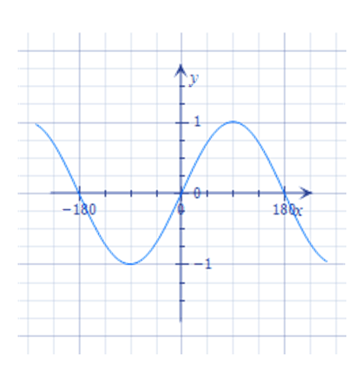
Draw another example of a continuous function.

Is the function above even or odd or neither?

DISCONTINUITY

A ____________ in the graph of a function is called a point of __________________________
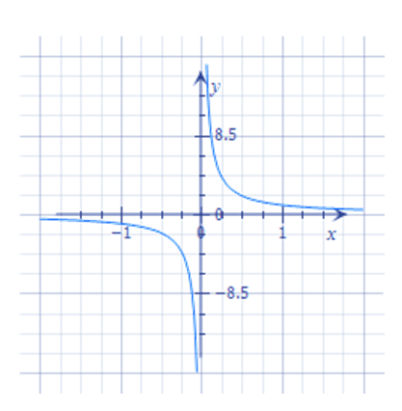
Draw another example of a discontinuous function.

Is the function displayed on the left even, odd or neither?

INVESTIGATING OUR 7 PARENT FUNCTIONS
Function | Intervals of Increase | Intervals of Decrease | Odd or Even? | Horizontal/  Vertical Asymptotes | End Behaviours | Continuous or Discontinuous | Domain and Range | Zeros
$$y=x$$

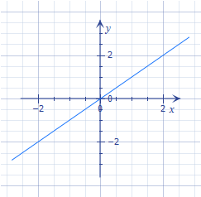

$$y=x^{2}$$

Function | Intervals of Increase | Intervals of Decrease | Odd or Even? | Horizontal/  Vertical Asymptotes | End Behaviours | Continuous or Discontinuous | Domain and Range | Zeros
$$y=\frac{1}{x}$$

$$y=\left|x\right|$$

Function | Intervals of Increase | Intervals of Decrease | Odd or Even? | Horizontal/  Vertical Asymptotes | End Behaviours | Continuous or Discontinuous | Domain and Range | Zeros
$$y=\sqrt{x}$$
$$y=2^{x}$$

Function | Intervals of Increase | Intervals of Decrease | Odd or Even? | Horizontal/  Vertical Asymptotes | End Behaviours | Continuous or Discontinuous | Domain and Range | Zeros
$$y=\sin{x}$$

