1.2 Absolute Value

An average person's blood pressure is dependent on their age and gender. For example, the average systolic blood pressure, P_{n}, for a 17-year-old girl is about 127 mm Hg (The symbol mm Hg stands for millimeters of mercury, which is a unit of measure for blood pressure). The average systolic blood pressure for a 17-year-old boy is about 134 mm Hg.

When doctors measure blood pressure, they compare the blood pressure to the average blood pressure for people the same age and gender group. This comparison, P_{d}, is calculated using the formula P_{d} = │ P - P_{n} │, where P is the blood pressure reading and P_{n} is the average reading for people of the same age and gender group.

A. Jim is a 17-year old boy whose most recent blood pressure reading was 142 mm Hg. Calculate P_{d} for Jim.

B. Joe is a 17-year old boy whose most recent blood pressure reading was 126mm Hg. Calculate P_{d} for Joe.

C. Compare the values A. and B. What do you notice? How are the answers interesting?

D. Complete the following table by calculating the values of P_{d} for the given blood pressure readings of 17-year-old boys.

Blood Pressure Reading, P | 95 | 105 | 115 | 125 | 135 | 145 | 155 | 165
P_{d}

E. Draw a scatter plot of P_{d} as a function of blood pressure, P.

F. Describe these characteristics of your graph:

i) domain

ii) range

iii) zeros

iv) existence of any asymptotes

v) shape of graph

vi) intervals of the domain in which the values of P_{d} are increasing and decreasing

vii) behaviour of the values of the function P_{d} as P becomes larger and smaller

REFLECTING

1. Why might your predict the range of your graph to be greater than or equal to zero?

2. What other function with domain greater than P_{n}, could you have used to plot the right side of your graph? Why does this make sense?

3. What other function with domain less than P_{n} could you have used to plot the left side of your graph? Why does this make sense?

4. How will the graph of y = ΙxΙ compare with the graph of P_{d} = ΙP-P_{n}Ι, if P_{d} is the y-coordinate and P is the x-coordinate?

SUMMARTY: So what does the absolute value of a number mean?

f(x) = Ι x Ι is the absolute value function.

On a number line, this function describes the distance, f(x), of any number x from the origin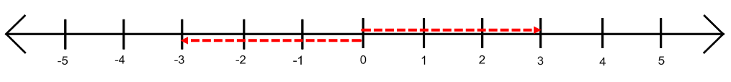
Homework: Section 1.2 #3-11

