**Trig Ratios in Right Triangles**

**Unit 6: Lesson 1**

http://t0.gstatic.com/images?q=tbn:ANd9GcQDQu_H3NQWf5kM0CUMwUknODmOjqDIB1gYGzfeiegVVs5cIf9ceaBWzWQf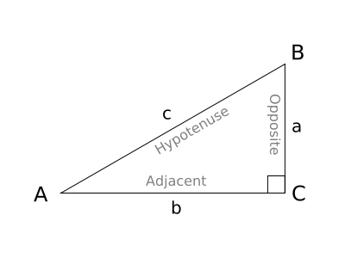

**STEP 1: Always LABLE TRIANGLES in this order: H, O, A**

**FINDING A MISSING SIDE IN A TRIANGLE -** To find a missing side in a right triangle use SIN, COS or TAN.

Example 1: Determine the length of x.



Example 2: Determine the length of x.



Example 3:

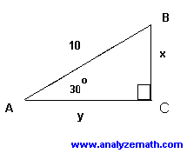

Pg 8 #3

**FINDING A MISING ANGLE IN A RIGHT TRIANGLE -** To find a missing side in a right triangle use SIN-1, COS-1 or TAN-1.

Example 1: Determine the measure of the indicated angle.



Example 2: Determine the measure of angle A.

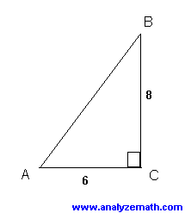

Pg 9 #5

**BEARING**

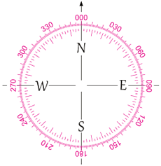

North is bearing 000˚

South is bearing 180˚

South West is bearing 225˚

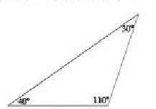 **Step 1: Place a compass at the point where you are calculating the bearing**

**Step 2: Calculate the number of degrees from North to the line of travel going CLOCKWISE.**

**WORD PROBLEMS**

**Example 1:** Zahraa and Bashir want to determine the height of a wind turbine. Zahraa stands 60.0 feet from the base of the turbine. She measures the angle of elevation to the top of the turbine to be 81 degrees. On the other side of the turbine, Bashir measures an angle of elevation of 76 degrees. Bashir and Zahraa are 4.8 feet above the ground when they measure the angle of elevation.

1. Make a sketch of the situation.
2. What is the height of the wind turbine?
3. How far from the base is Bashir?

**Example 2:** Suzette is drawing a map of a triangular plot of land.

1. Determine the angles in the triangle.
2. Determine the bearing of the third side of the plot, AB.

**Homework pg 10 #9-16 *12* *16\***

C

B

A

1.8km

1.2km