Volume and Surface Area with Mixed Imperial
Unit 5 – Lesson 7
- Cosider the bales of hale below.
- Determine the volume in m³ of the hay in a bale.
- Determine the area in m² of the shrink-wrap protective cover placed on the bale.
- How much shrink-wrap is needed if the wrap does not cover the ends of the roll?

5’ 9’’
5’ 4’’

- Determine the volume of this shed in cubic metres.
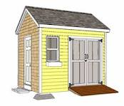
8’ 4’’
5’ 2’’
7’ 4’’
2’ 4’’

- Determine the surface area of the shed above.

- Homework: pg 81-85 #2,3,4,5,6,11,12,15,16,17

