Unit 3: Mathematical Models - Mid-Unit Review
x | y | First Difference | Second Difference | Finite Ratio (of the y-values)
-1 | -3
0 | 0
1 | 3
2 | 6
3 | 9
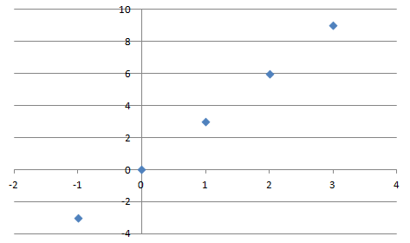
CIRCLE THE TYPE OF RELATIONSHIP:
QUADRATIC, EXPONENTIAL, LINEAR
$y=a∙b^{x}$, $y=mx+b$ ,$y=a{\left(x-k\right)}^{2}+h$
Choose the correct equation above and make an algebraic model for the table.

x | y | First Difference | Second Difference | Finite Ratio (of the y-values)
-1 | 3
0 | 0
1 | 3
2 | 12
3 | 27

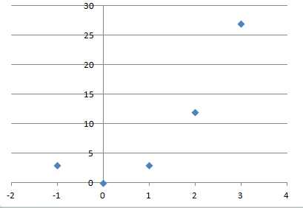
CIRCLE THE TYPE OF RELATIONSHIP:
QUADRATIC, EXPONENTIAL, LINEAR
$y=a∙b^{x}$, $y=mx+b$ ,$y=a{\left(x-k\right)}^{2}+h$
Choose the correct equation above and make an algebraic model for the table.

x | y | First Difference | Second Difference | Finite Ratio (of the y-values)
-1 | 0.66666
0 | 2
1 | 6
2 | 18
3 | 54
CIRCLE THE TYPE OF RELATIONSHIP:
QUADRATIC, EXPONENTIAL, LINEAR
$y=a∙b^{x}$, $y=mx+b$ ,$y=a{\left(x-k\right)}^{2}+h$
Choose the correct equation above and make an algebraic model for the table.

What will the y-value be when x=7?

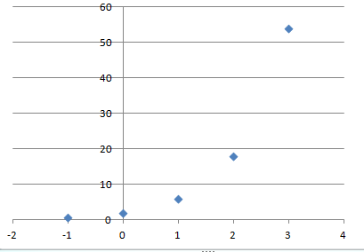

Which of the three types of relationships has the largest growth rate?
Which has a CONSTANT rate of change?
Which have CHANGING rate of change?
Review of Working with Exponents
Write as a single power and then simplify.
- $5^{4}×5^{-5}$

- $\frac{{(-6)}^{2}}{{(-6)}^{-1}}$

- ${(m^{5})}^{-3}$

- ${\left(\frac{1}{z^{3}}\right)}^{-6}$
Evaluate each expression if a=1, b=-2.
- $\frac{a^{2}a^{-5}}{{{(a}^{-2})}^{3}}$

- ${(2a^{2}b)}^{5}$

