MAP4C – Scatter Plots

PART A:
For each scatter plot below:
a) Describe the relationship between the independent variable and the dependent variable.
b) Decide if you would you model the relationship with a linear or non-linear model? Justify your answer.
c) Describe the correlation as strong positive, weak positive, strong negative or weak negative, no correlation

i)
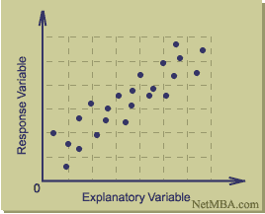

As the independent variable increases _________________________________

_______________________________________________________________________

I would model the relationship using a _________________________ model

because ______________________________________________________________

The correlation is _______________________________________________________

ii)
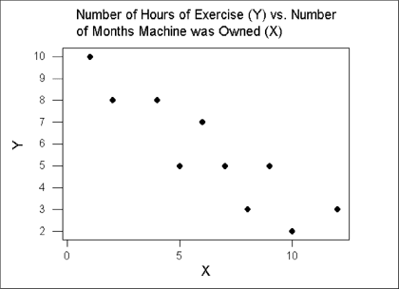

As the independent variable increases _________________________________
_______________________________________________________________________

I would model the relationship using a _________________________ model

because ______________________________________________________________

The correlation is _______________________________________________________

iii)
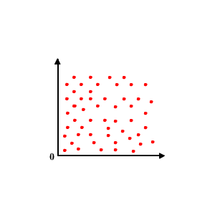

As the independent variable increases _________________________________

_______________________________________________________________________

I would model the relationship using a _________________________ model

because ______________________________________________________________

The correlation is _______________________________________________________

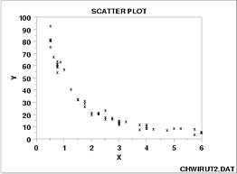
iv)

As the independent variable increases _________________________________

_______________________________________________________________________

_______________________________________________________________________

I would model the relationship using a _________________________ model

because ______________________________________________________________

_______________________________________________________________________

PART B:
A linear model may be unreliable if:
- The model is based on too few pieces of information
- The model is based on data that are clustered together
- There does not appear to be any correlation
- There are outliers
- The data do not appear to be linear

Look at the following scatter plots displayed below and determine why the linear model used may be unreliable.
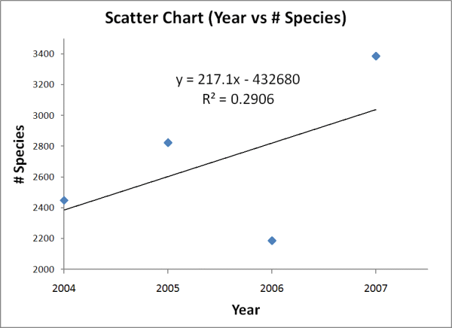
i)

The linear model may be unreliable because ____________________________

________________________________________________________________________

________________________________________________________________________

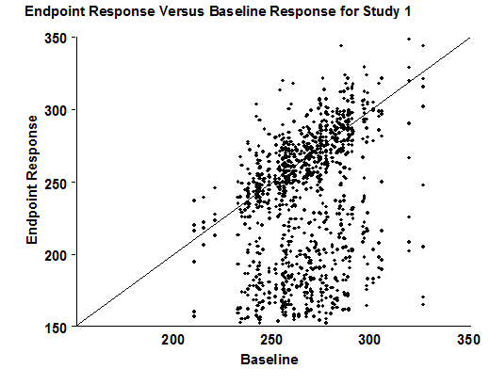
ii)

The linear model may be unreliable because ____________________________

________________________________________________________________________

________________________________________________________________________

iii)
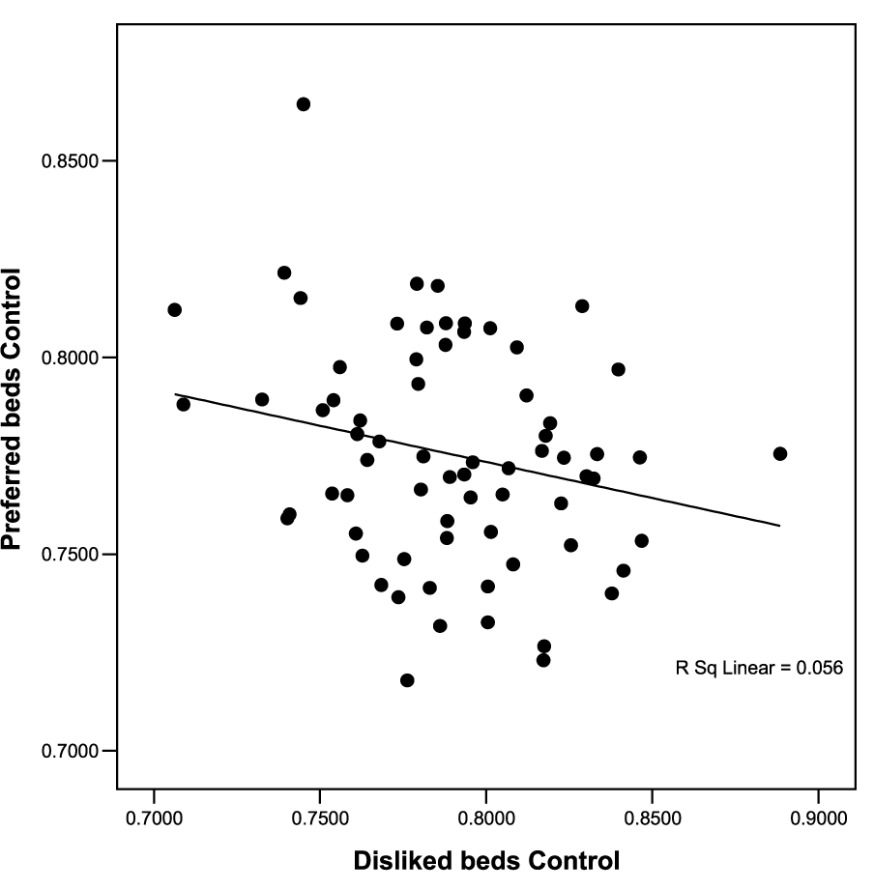

The linear model may be unreliable because ____________________________

________________________________________________________________________

________________________________________________________________________
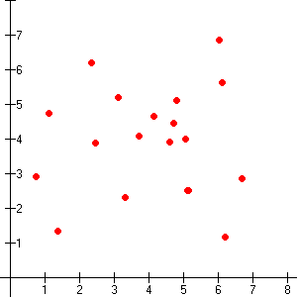

The linear model may be unreliable because ____________________________

________________________________________________________________________

________________________________________________________________________
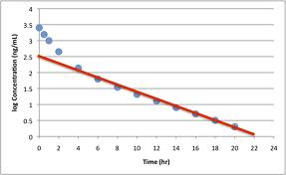

The linear model may be unreliable because ____________________________

________________________________________________________________________

________________________________________________________________________

PART C: pg 156 #10

