Unit 2: Indices
What about prices in general? As a class, list 10 items that students regularly purchase.
Items | Price in 2008 (Price in Grade 8) | Price in 2012 (Current Price)

How could you determine the percent change in the price of item 4?
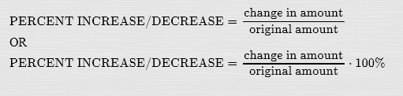

In your group, pick the 5 items from the list above that are most essential to your group members and record them below.
Essential Items | Price in 2008 | Price in 2012
1.
2.
3.
4.
5.

Determine whether the price of your “basket of goods” has increased or decreased since 2008? And by how much?

Which group had the basket whose price changed the most? Why?

Who do you think has these items in their basket of essential items?

Tuition fees
Drivers’ licences
Parking
Auto insurance
City bus and subways
Newspapers
Furniture
Footwear
Dental Care
Use of recreation facilities and services
Cable Television
Property taxes
Child care
Telephone services
Home entertainment equipment and services
Lettuce
Apples
Oranges
Fresh or frozen chicken
Eggs
Electricity
Water
Pet Food and Supplies

What is the Canadian CPI?

Below is a graph of the Canadian CPI from 1987 until 2007.

1. Describe the trend that you see? What does this mean about prices, in general, in Canada?

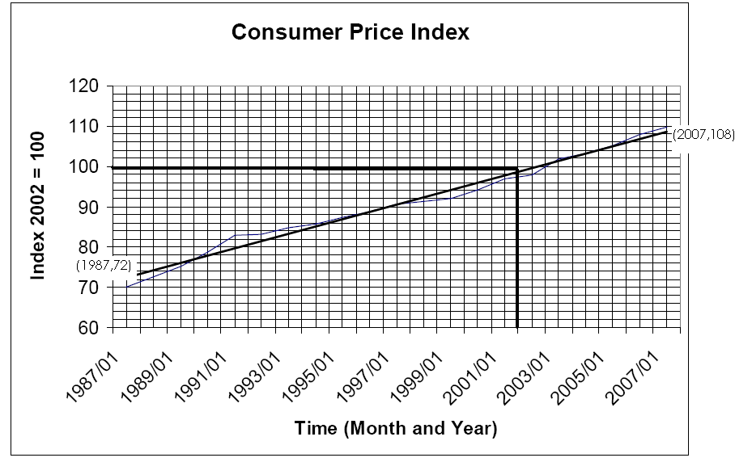

2. What do you think Index 2002=100 means? And given what you think it means, what do the points (2007, 108) and (1987, 72) tell you about prices in 2007 and 1987?

3. How much have prices rose between 1987 and 2007? (Hint: Remember the formula that you used on page 1)

4. If the index in 1993 is 82 and the index in 2005 is 105, how much have prices rose between 1993 and 2005?

5. The price of a pair of jeans in 2002 was $64.99. Based on the CPI, estimate what the same pair of jeans would cost in 2007?

6. If a cell phone costs $129.99 in January 2007, according to the CPI, what would the same cell phone have cost in 1997?

7. What is wrong with the question and answer above?

Now you try:
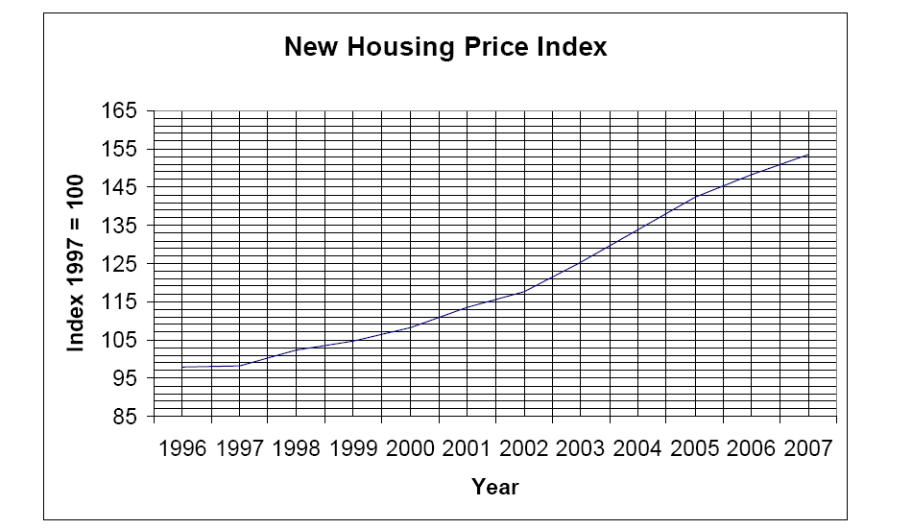
- What is happening to the prices of new houses over time? Why?
- Pick any two years and determine how much prices have changed between the two years.
- If a house cost $154 000 in the earlier year , how much would a similar house cost in later year?

Mrs Moodie has been shopping for a new TV for over a year. Mrs Moodie went shopping for a television this weekend. The TV she wants to buy costs $429. She is pleasantly surprised because the same model costs $799 last year when she was shopping. That is a 46% drop in price!!! Mrs. Moodie has concluded that prices of things in general are falling. Do you agree or disagree? Justify your thinking.

