Scatterplots and Lines of Best Fit

What is a scatterplot? ______________________________________________________________________________

___________________________________________________________________________________________________

What is a line of best fit? ___________________________________________________________________________

___________________________________________________________________________________________________

What is the value in creating a scatterplot and a line of best fit? _____________________________________

___________________________________________________________________________________________________
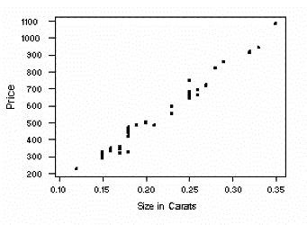

What do you learn from this scatterplot?

Draw a line of best fit?

What would you expect to be the price of a 0.22
carat diamond?

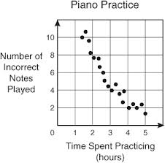

What do you learn from this scatterplot?

Draw a line of best fit?

How many incorrect notes would you expect to make
if you practiced for 2.5 hours?

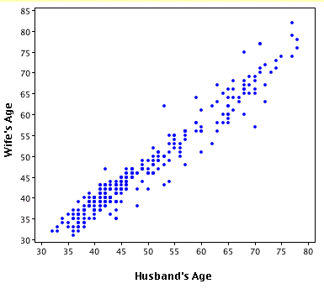

What do you learn from this scatterplot?

Draw a line of best fit?

How old would you expect the wife to be of a husband who is 75 years old?

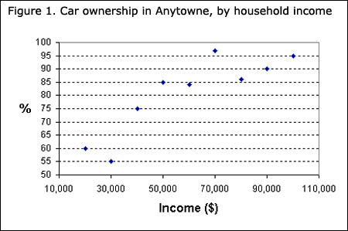
What do you learn from this scatterplot?

Draw a line of best fit?

What percentage of people earning $40 000
would you expect to own a car?

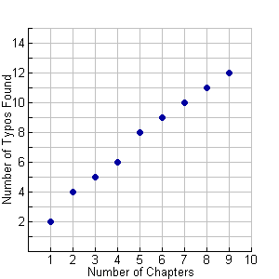
What do you learn from this scatterplot?

Draw a line of best fit?

How many typos would you expect to find in a book with
11 chapters?

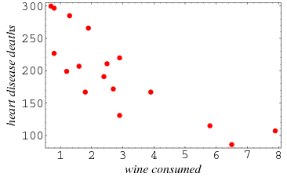

What do you learn from this scatterplot?

Draw a line of best fit?

How many heart disease deaths would you expect to find
in the group of people who consume 5 glasses of wine
a week?

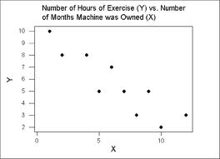

What do you learn from this scatterplot?

Draw a line of best fit?

How many hours would you expect someone
to exercise if they had owned their machine
for 2.5 years?

