Graphing Exponential Functions Assignment

Graphing Exponentials | R | 1 | 2 | 3 | 4

$$y=2∙5^{3\left(x+4\right)}+6$$
a= 2 ➔ multiply y by 2
k = 3 ➔ divide x by 3
d ➔ translate left 4 so subtract 4 from the x’s
c ➔ translate up 6 so add 6 to the y’s

Do you multiply or divide anything by 5? NO!!! It is just the base of the power. You only use the 5^{x} to make the parent table.

x | y = 5^{x}
-2 | 5⁻² = 0.04
-1 | 5⁻¹ = 0.2
0 | 5⁰ = 1
1 | 5¹ = 5
2 | 5² = 25

What do we do to the x’s? Divide all x by 3 and then subtract 4
What do we do to the y’s? Multiply all y by 2 and then add 6

x ÷ 3 -4 | y · 2 + 6
-2 | 6.08
-1 | 6.4
0 | 8
1 | 16
2 | 56

To Graph: 1. Plot asymptote at y= 6
2. Determine the shape of graph. (regular since not reflected at all)
3. Plot points.
4. Draw graph.

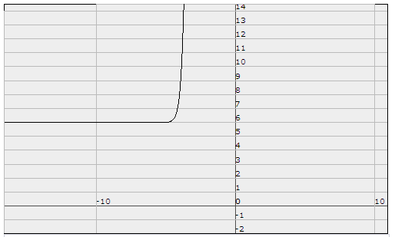
NOW YOU TRY:

1. y = 3 ^{-2(x-6)} -1

Is there an a? NO

Is there a k? YES. What is it? __________________________

Is there any reflections? YES. Which type? ___________________

What is the parent function? y = 3^{x}

Make the parent table.

x | y = 3^{x}
-2
-1
0
1
2

Make the table for the transformed function, y = 3 ^{-2(x-6)} -1

x | y

What is the equation of the asymptote?

y = _________

y=3^{x} is moved right, moved down and reflected in the y-axis. Which of the following should it look like?
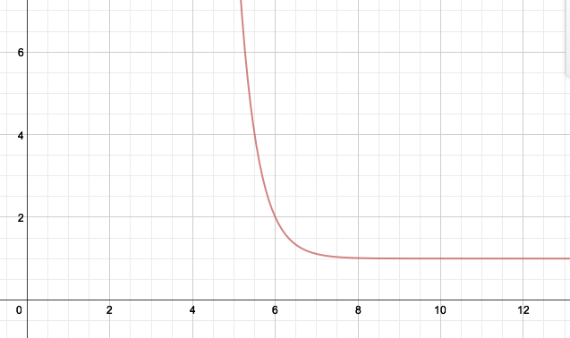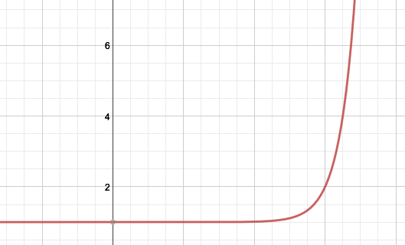

Sketch the function.

2. y = - 2 · 4 ^{(x+1)}

Is there an a or a k? _______ Are there any reflections? Which type? ___________________

What is the parent function? ____________

Make the parent table.
x
-2
-1
0
1
2

Make the table for the transformed function, y = - 2 · 4 ^{(x+1)}

x | y

What is the equation of the asymptote? y = _________

Sketch the function.

