Solutions to Assignment 1b

$y=5f\left(-2\left(x-4\right)\right)+ 2$, where $f\left(x\right)= \frac{1}{x}$

x | y | x/-2 | x/-2 + 4 | y *5 | y* 5 + 2
-10 | -0.1 | 5 | 9 | -0.5 | 1.5
-1 | -1 | 0.5 | 4.5 | -5 | -3
-0.1 | -10 | 0.05 | 4.05 | -50 | -48
0.1 | 10 | -0.05 | 3.95 | 50 | 52
1 | 1 | -0.5 | 3.5 | 5 | 7
10 | 0.1 | -5 | -1 | 0.5 | 2.5

$$y=5\left(\frac{1}{-2(x-4)}\right)+ 2$$
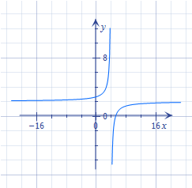
$$D= \{\left.x∈R\right| x≠4\}$$
$$R= \{\left.y∈R\right| y≠2\}$$

$y= -0.5f\left(x+4\right)- 2,$ where $f\left(x\right)= \left|x\right|$
x | y | x-4 | y*-0.5 | y*-0.5 - 2
-2 | 2 | -6 | -1 | -3
-1 | 1 | -5 | -0.5 | -2.5
0 | 0 | -4 | 0 | -2
1 | 1 | -3 | -0.5 | -2.5
2 | 2 | -2 | -1 | -3
$$y=-0.5\left|x+4\right|-2$$
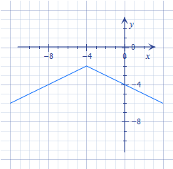

$$D= \{ x∈R\}$$
$$R= \{\left.y∈R\right| y≤-2\}$$

$y=-3f\left(4x-16\right)+ 1,$ where $f\left(x\right)=x^{2}$
FACTOR OUT 4
$$y=-3f\left(4(x-4)\right)+ 1$$
x | y | x/4 | x/4+4 | y*-3 | y*-3+1
-2 | 4 | -0.5 | 3.5 | -12 | -11
-1 | 1 | -0.25 | 3.75 | -3 | -2
0 | 0 | 0 | 4 | 0 | 1
1 | 1 | 0.25 | 4.25 | -3 | -2
2 | 4 | 0.5 | 4.5 | -12 | -11

$$y=-3{(4\left(x-4\right))}^{2}+1$$

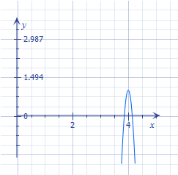
$$D= \{ x∈R\}$$
$$R= \{\left.y∈R\right| y≤1\}$$

