Chapter 1 Assignment
Consider the function $y=2f\left(-4\left(x-6\right)\right)+ 1$, where $f\left(x\right)=\sqrt{x}$.
- Rewrite the function using the square root function.
$$y=2\sqrt{-4(x-6)}+1$$
- Make a table for the parent function.
$$x$$ | $$y$$
0 | 0
1 | 1
4 | 2
9 | 3
- Make a table for the transformed function.
$$x$$ | $$y$$
$$0 ÷-4+6=6$$ | $$0 ×2+1=1$$
$$1 ÷-4+6=5.75$$ | $$1×2+1=3$$
$$4 ÷-4+6=5$$ | $$2×2+1=5$$
$$9 ÷-4+6=3.75$$ | $$3 ×2+1=7$$
- Describe the transformation done to the parent function.
Complete a) to f) for the following functions:
- $y=-4f\left(5\left(x+2\right)\right)- 3$ where $f\left(x\right)=\frac{1}{x}$
- $y=-f\left(-2\left(x-1\right)\right)+ 3$ where $f\left(x\right)=\left|x\right|$
- $y=3f\left(-2x+6\right)+ 1$ where $f\left(x\right)=x^{2}$ (HINT factor out the -2 first)

- Vertical Stretch of factor 2
- Horizontal compression
- Reflection in the y-axis
- Translated 6 units to the right
- Translated 1 unit up

- Make an accurate sketch of the function.
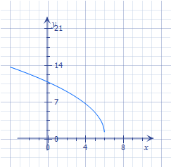
- State the domain and range of the function.
$$D= \left\{x∈R | x≤6\right\}$$
$$R= \left\{y∈R | y≥1\right\}$$

SOLUTIONS:
$$y=\frac{-4}{5(x+2)}- 3$$

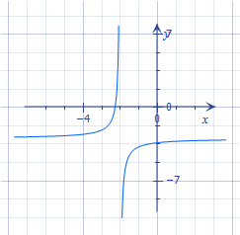
$$D= \left\{x∈R | x≠-2\right\}$$
$$R= \left\{y∈R | y≠-3\right\}$$
$$y=-\left|-2(x-1)\right|+3$$
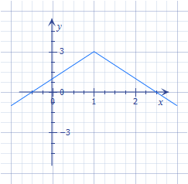
$$D=\{x∈R\}$$
$$R= \left\{y∈R | y≤3\right\}$$

$$y=3{\left(-2(x-3)\right)}^{2}+ 1$$
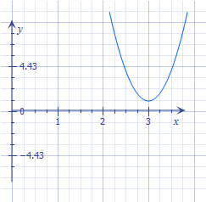
$$D=\{x∈R\}$$
$$R= \left\{y∈R | y≥1\right\}$$

