**5.7: The Cosine Law**

**Recall from last class: The Sine Law**

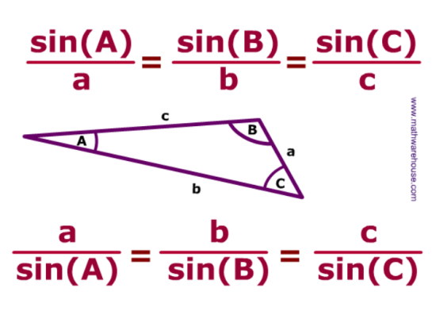

**Step 1:** Can you use SohCahToa to solve for c? Why not? ___________________________________

Can you use Sine Law to solve for c? Why not? ______________________________________

c

60°

C

A

B

12 *cm*

26 *cm*

**New Today: The Cosine Law**

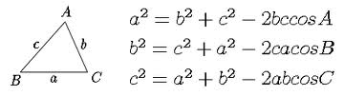

**Step 2:** Fill in the blanks.

If you are trying to find a missing angle or side in a triangle follow these steps:

1. Is the triangle a ________________ triangle? If yes, use S __ __ C __ __ T __ __.
2. Do we have an opposite side and angle and at least one other side or angle? If yes, use the _________ law.
3. If you don’t have an angle and side opposite to one another then you must use the ____________ law.

**Step 3:** Go to page 325 to answer the following question.

The cosine law can be used if you know

* _______ sides and the angle _________________ between those sides
* All three ________.

**Step 4:** Find the triangle for which the cosine law cannot be used. Explain why the cosine law will not work with this triangle.

10

19

17

23

15

17

86⁰

13

86⁰

**Step 5:** Consider the formulas for the cosine law in the box on the first page, what is true about the one letter on the left side of the equation and the final angle on the right side in all three cases?

**Step 6:** Consider the triangle ABC and notice how the cosine law is used to find x.

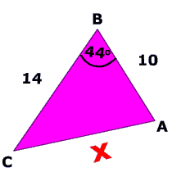 x² = 10² + 14² −2(10)(14)cos(44°)

x² = 296 −280cos(44)

x² = 94.6

http://www.mathwarehouse.com/trigonometry/images/law-of-cosines/formula.gif

**Step 7:** Now find the missing side in the following triangle using the same method.

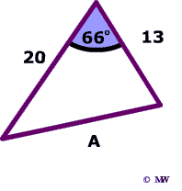

**Step 8:** Consider triangle ABC and notice how the cosine law is used to find angle x.

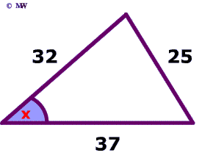

25² = 32² + 37² −2(32)(37)cos(x)

625 = 2393 − 2,368 cos(x)

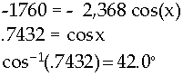

**Step 9:** Now find the missing angle (the shaded one) by using the same method as in step 8.

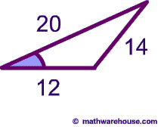

**Step 10:** In △ABC, determine ∠A to the nearest degree if a= 102 cm, b= 53 cm and c = 65 cm. (Look at example 2 on page 323 to help you)

**Step 11:** Complete #3a, b; 5, 6

3a. 3b.

5.

6.

**Step 12:** A barn whose cross-section resembles half a regular octagon (the interior angles in an octagon are 135⁰) with a side length of 12 m needs some repairs on the roof. The roofers place a 26.3 m ramp against the side of the building, forming an angle of 27⁰ with the ground. The ramp will be used to transport the materials needed for the repair. The base of the ramp is 17.8 m from the side of the building. (Look at Example 1 on page 321)

* Sketch a diagram of the problem
* Solve the problem

THIS QUESTION IS HARD! YOU MUST FOLLLOW EXAMPLE 1 CAREFULLY OR YOU WILL NOT BE ABLE TO COMPLETE THIS QUESTION.

**http://www.wonderhowto.com/how-to-use-cosine-law-303112/**

**This video really helps to explain cosine law. Start 1 minute in. Watch from 1:00-9:02**